Greeting Unfamiliar Dogs

# 1. Approaching Unfamiliar Animals

## 1.1 Welcome

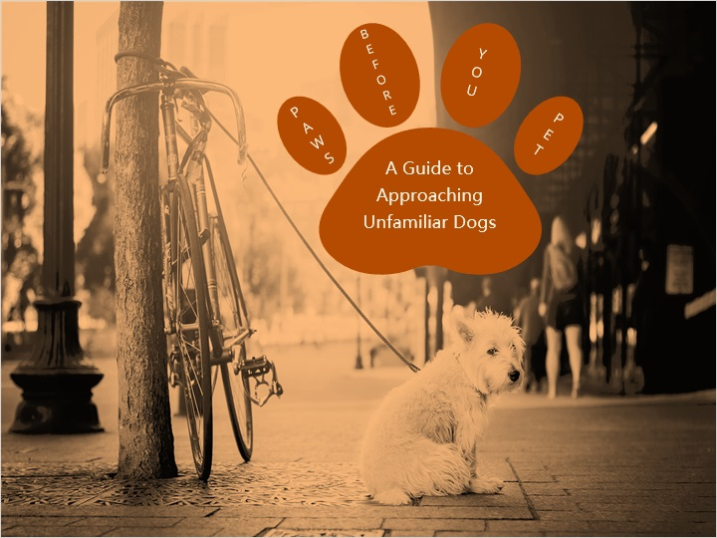

## 1.2 Course Objectives

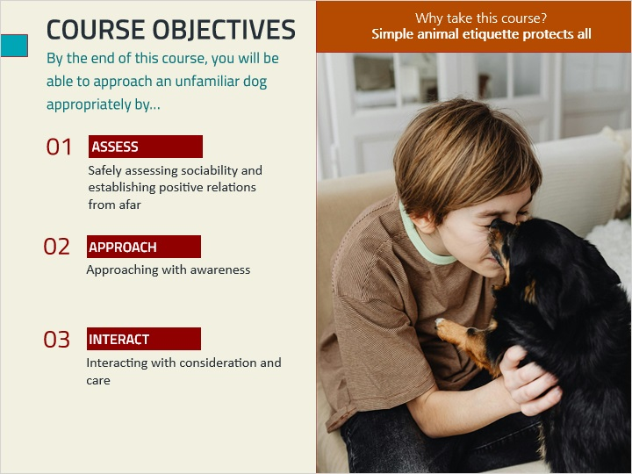

## 1.3 Pre Self-Assessment

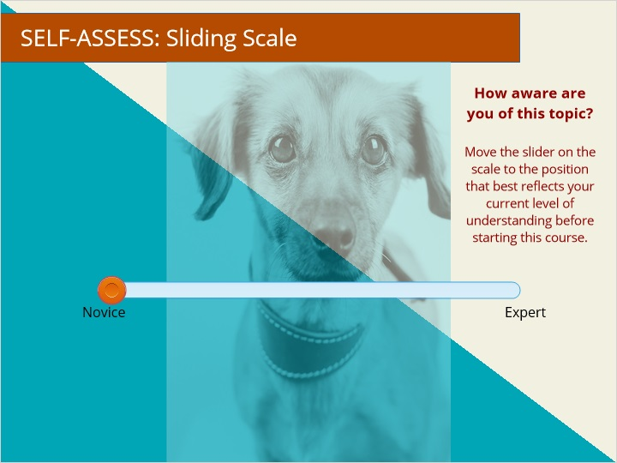

## 1.4 Pre-Assessment 1

*(True/False, 0 points, 1 attempt permitted)*

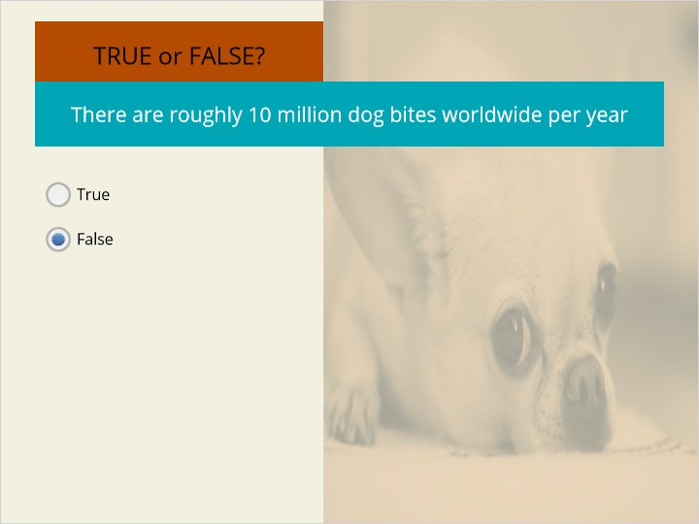

| Correct | Choice |
| --- | --- |
| True |  |
| False | X |

**Feedback when correct:**

According to the WHO, there are TENS of millions of dog bites worldwide per year, with an estimated 4.5 million bites per year in the United States alone.

**Feedback when incorrect:**

According to the WHO, there are TENS of millions of dog bites worldwide per year, with an estimated 4.5 million bites per year in the United States alone.

### Incorrect, it is FALSE (Slide Layer)



### Correct, it is FALSE (Slide Layer)

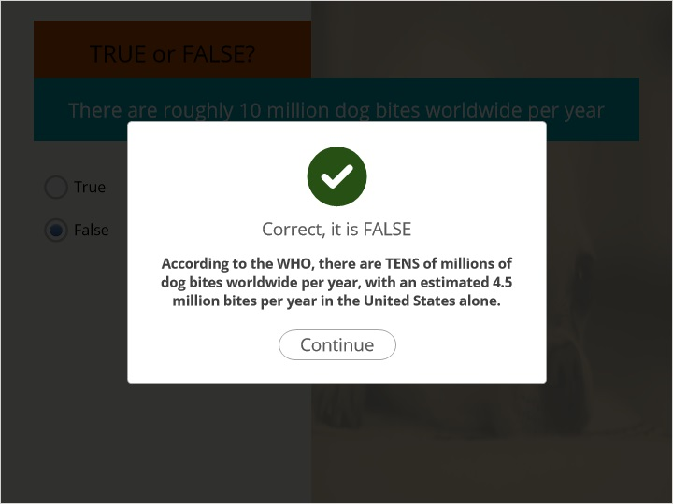

## 1.5 Pre-Assessment 2

*(True/False, 0 points, 1 attempt permitted)*

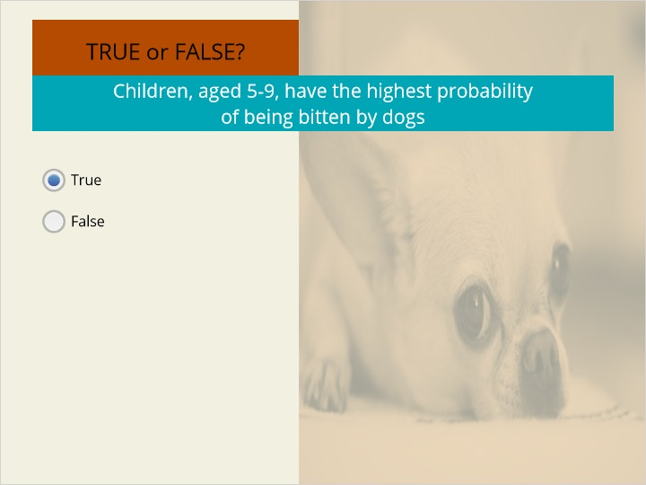

| Correct | Choice |
| --- | --- |
| True | X |
| False |  |

**Feedback when correct:**

Children are disproportionately bitten
compared to adults. They receive roughly 50%
of all dog bites with children, aged 5-9, receiving most bites

**Feedback when incorrect:**

Children are disproportionately bitten
compared to adults. They receive roughly 50%
of all dog bites with children, aged 5-9, receiving most bites

### Incorrect, it is TRUE (Slide Layer)

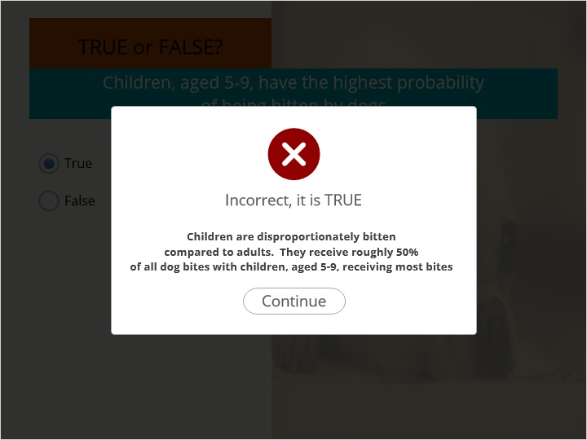

### Correct, it is TRUE (Slide Layer)

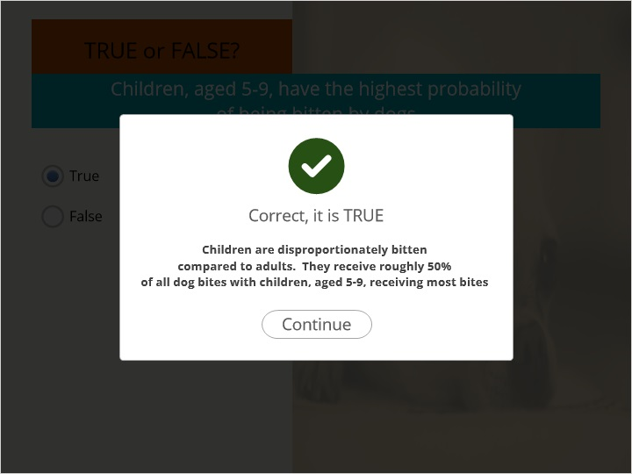

## 1.6 Dog-Bite Statistics: An Overview

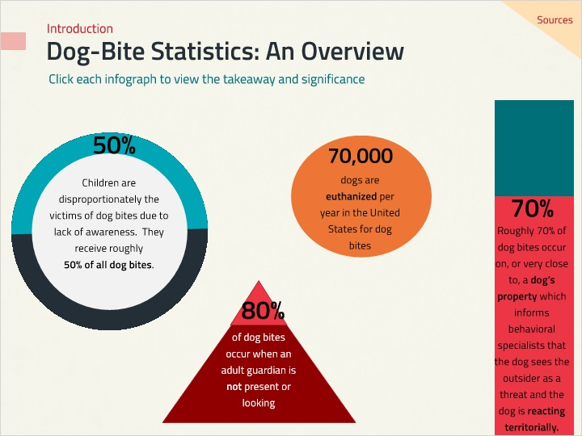

**Notes:**

### Untitled Layer 5 (Slide Layer)

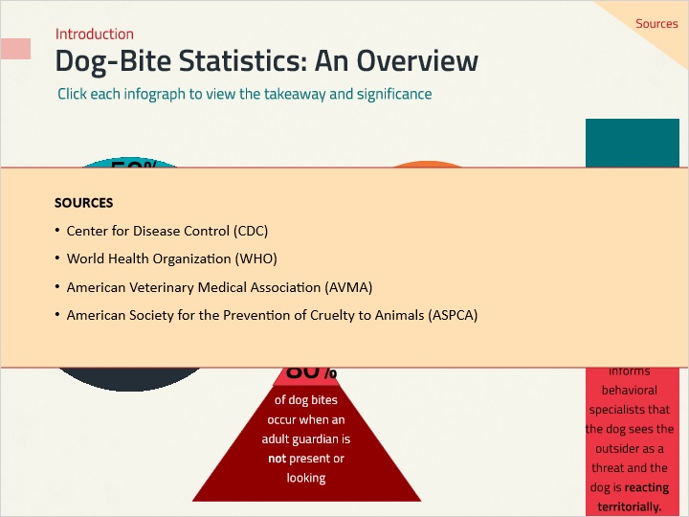

### Untitled Layer 4 (Slide Layer)

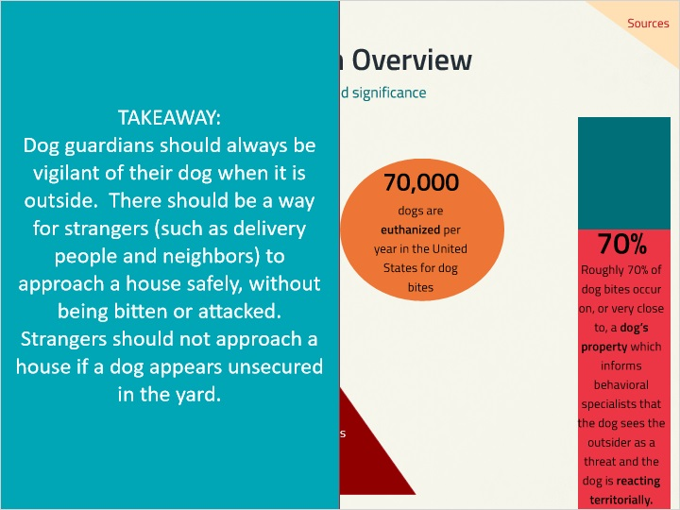

### Untitled Layer 3 (Slide Layer)

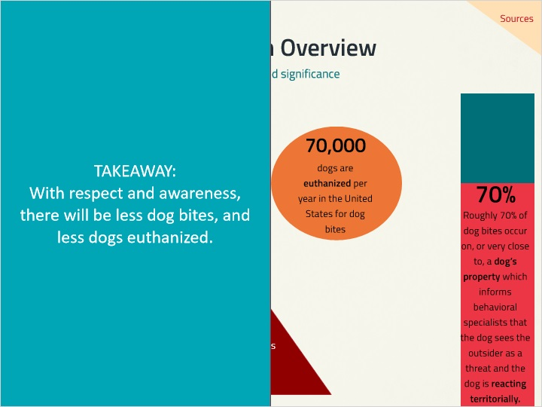

### Untitled Layer 2 (Slide Layer)

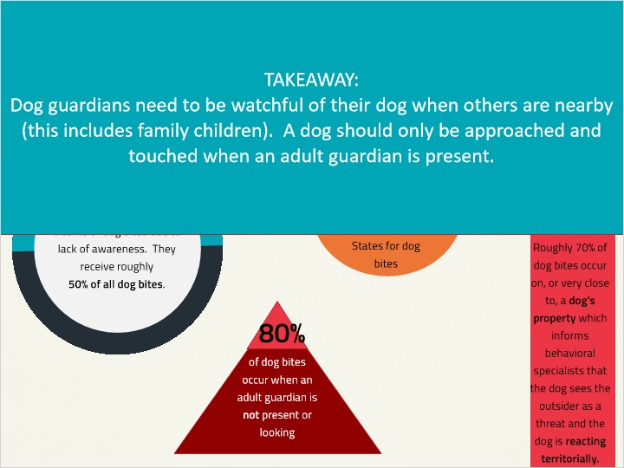

### Untitled Layer 1 (Slide Layer)

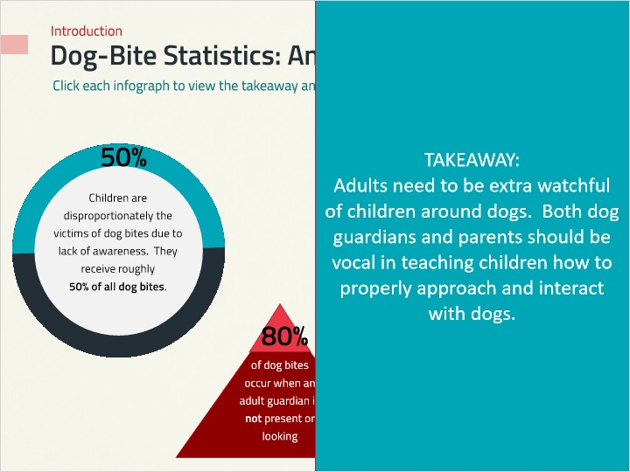

## 1.7 Step 1: Assessing from Afar

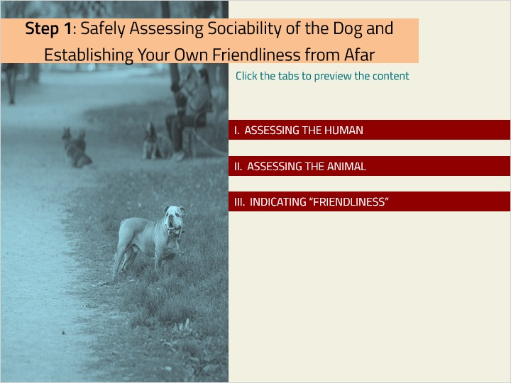

### Tab 03 (Slide Layer)

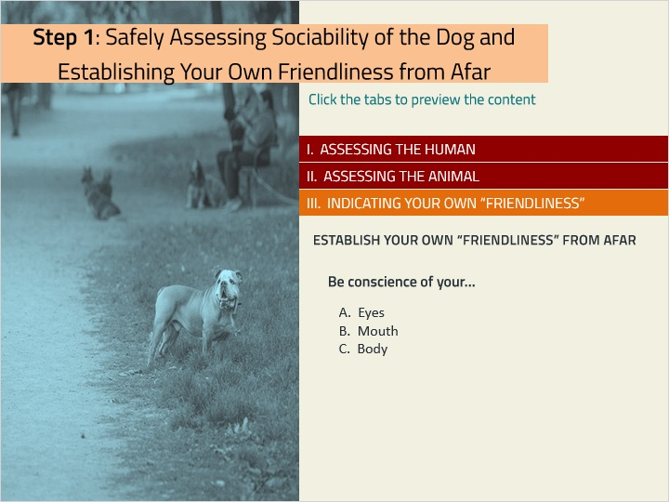

### Tab 02 (Slide Layer)

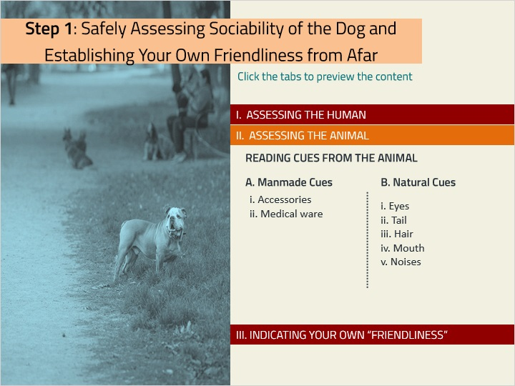

### Tab 01 (Slide Layer)

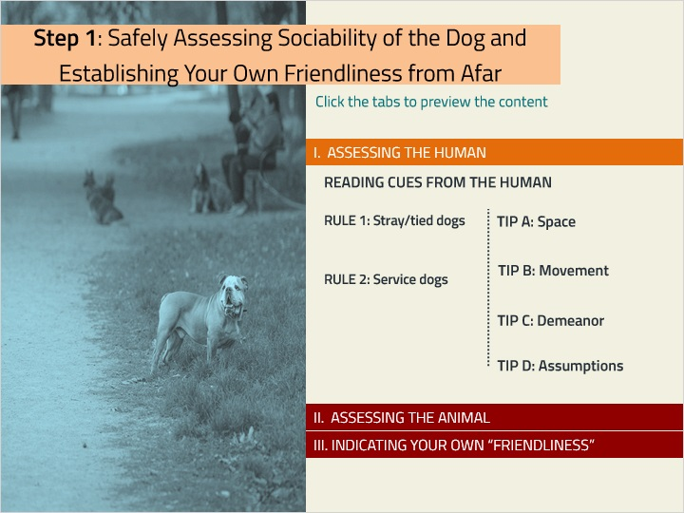

## 1.8 I. Reading Cues from the Human

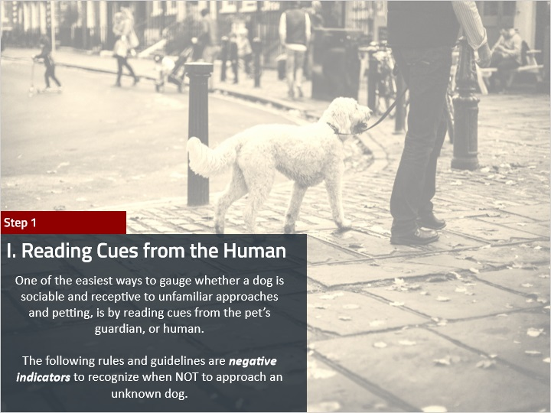

**Notes:**

## 1.9 I. Rules & Guidelines

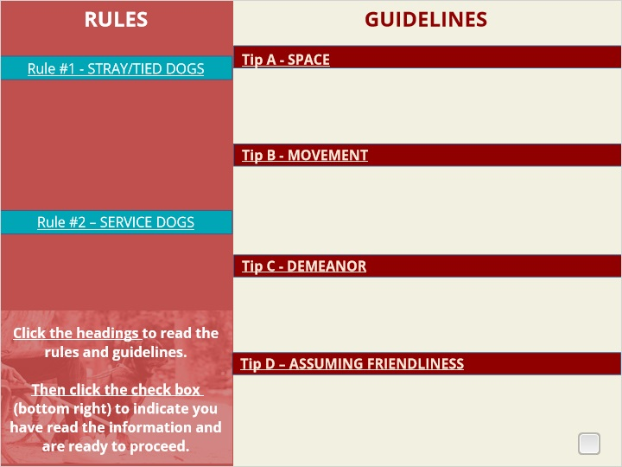

### Untitled Layer 6 (Slide Layer)

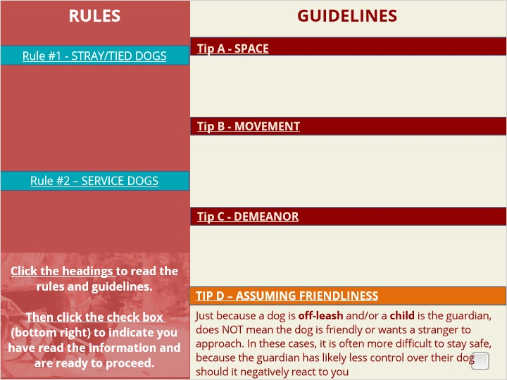

### Untitled Layer 5 (Slide Layer)

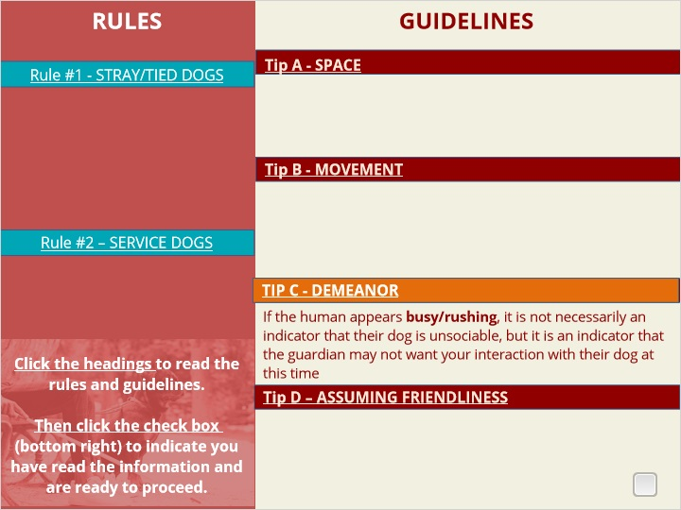

### Untitled Layer 4 (Slide Layer)

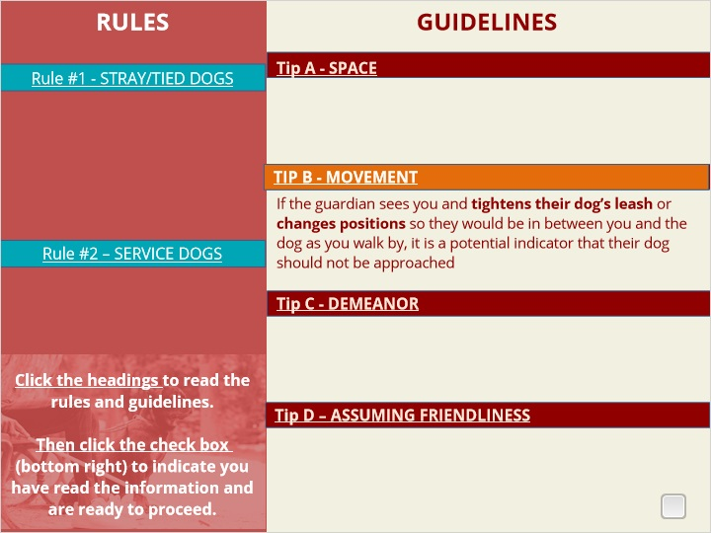

### Untitled Layer 3 (Slide Layer)

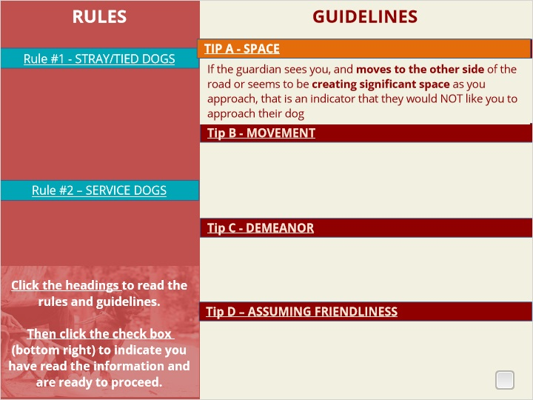

### Untitled Layer 2 (Slide Layer)

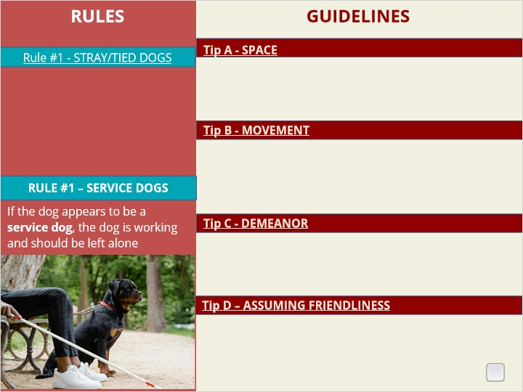

### Untitled Layer 1 (Slide Layer)

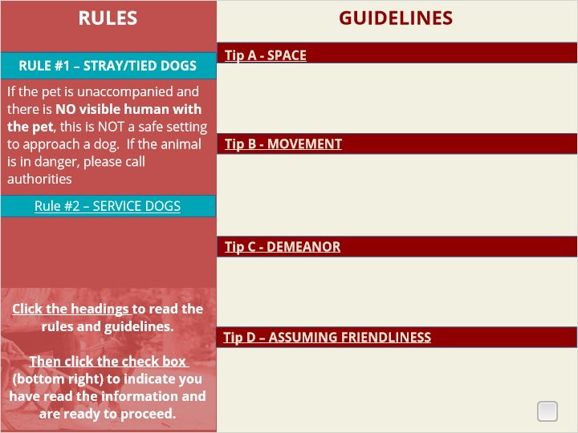

## 1.10 II. Reading Cues from the Animal

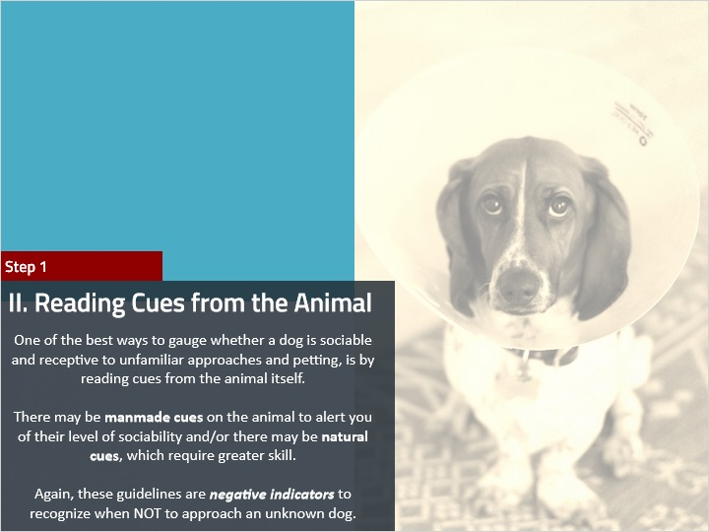

**Notes:**

## 1.11 II. Assessing Manmade Indicators on the Animal

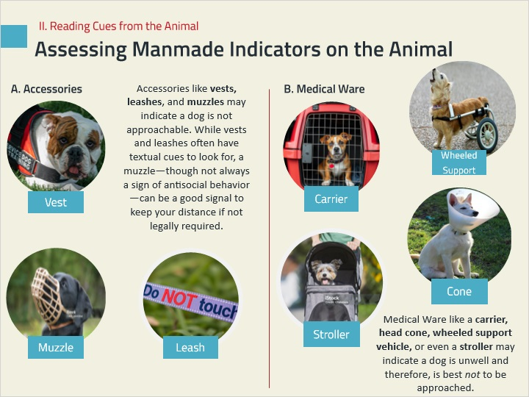

## 1.12 II.B Assessing Natural Cues

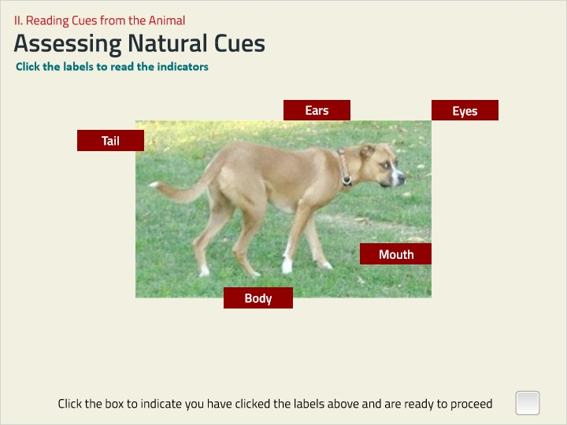

**Notes:**

### Untitled Layer 5 (Slide Layer)

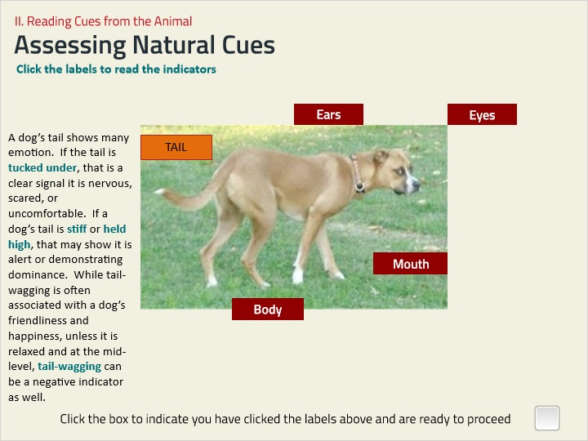

### Untitled Layer 4 (Slide Layer)

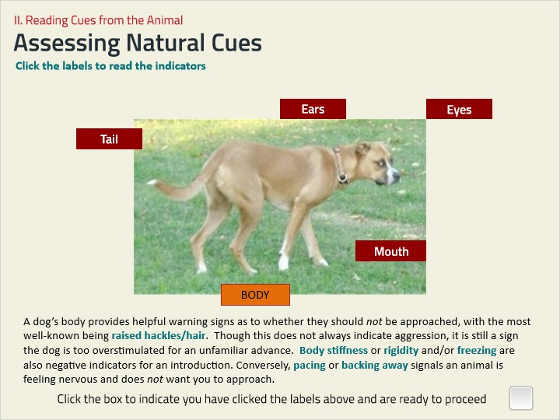

### Untitled Layer 3 (Slide Layer)

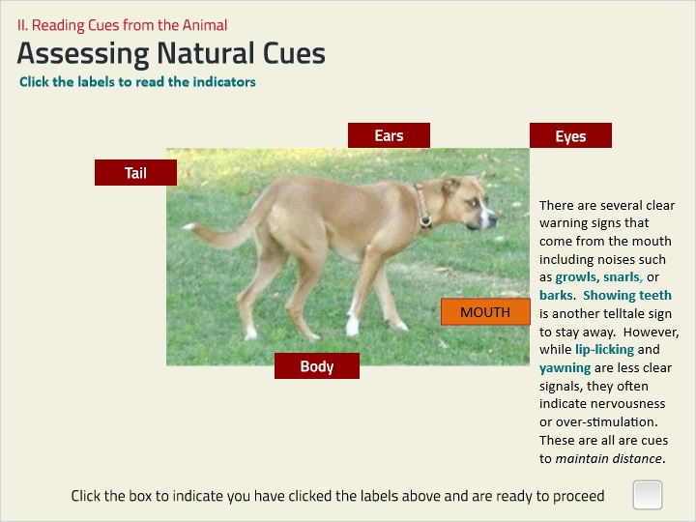

### Untitled Layer 2 (Slide Layer)

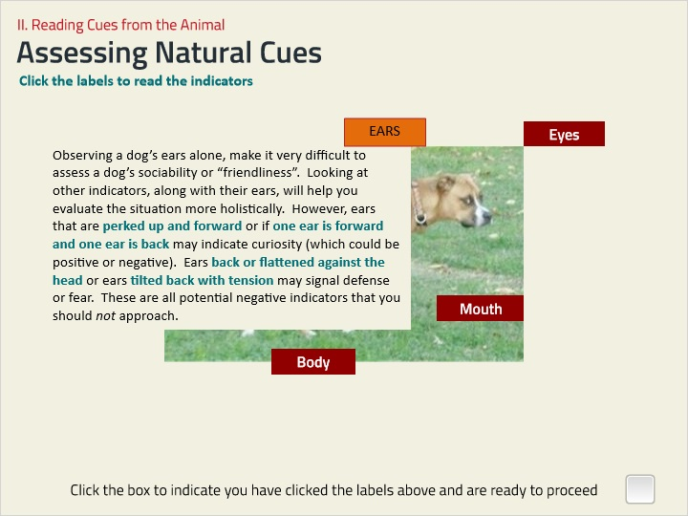

### Untitled Layer 1 (Slide Layer)

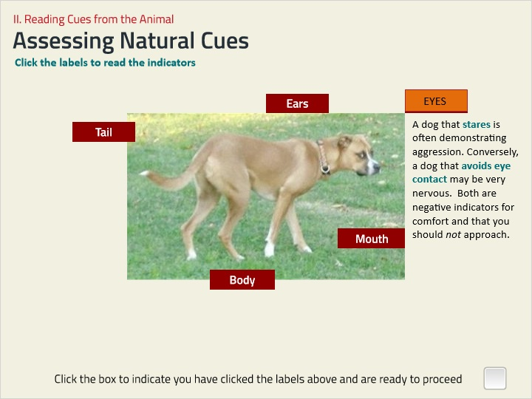

## 1.13 III. Indicating your Own “Friendliness”

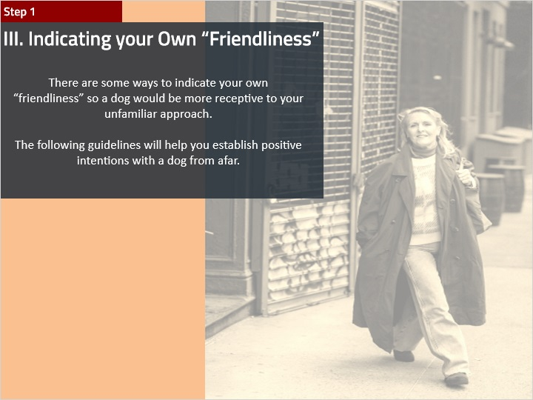

**Notes:**

## 1.14 III. Positive Indicators

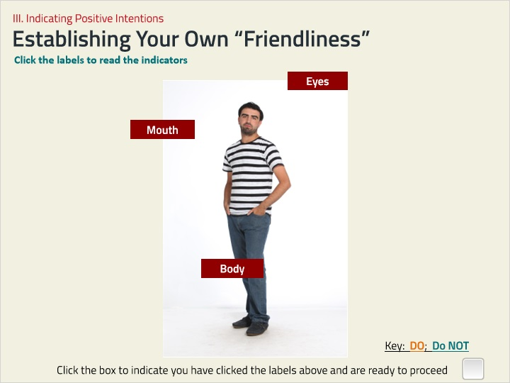

**Notes:**

### Untitled Layer 4 (Slide Layer)

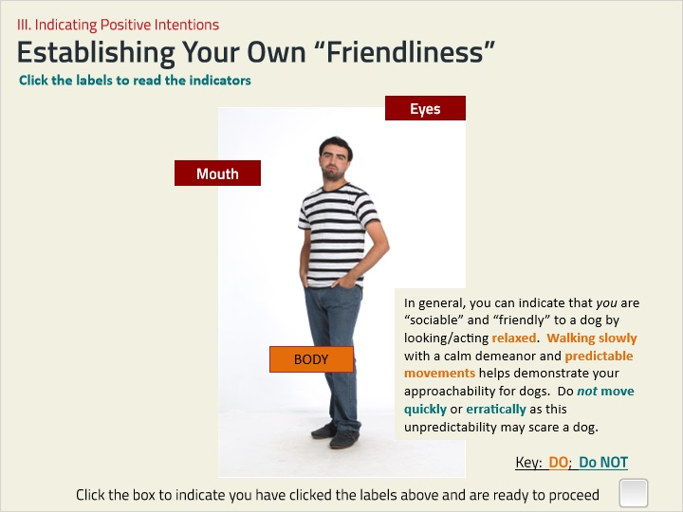

### Untitled Layer 3 (Slide Layer)

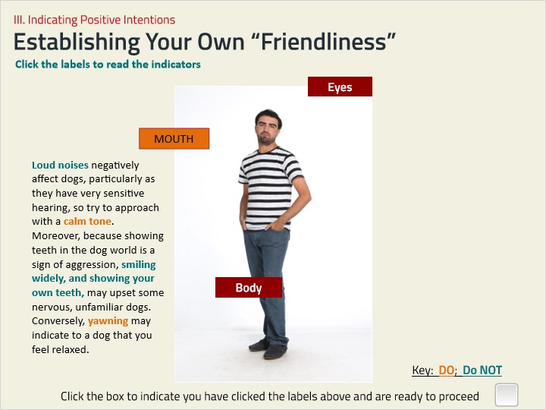

### Untitled Layer 1 (Slide Layer)

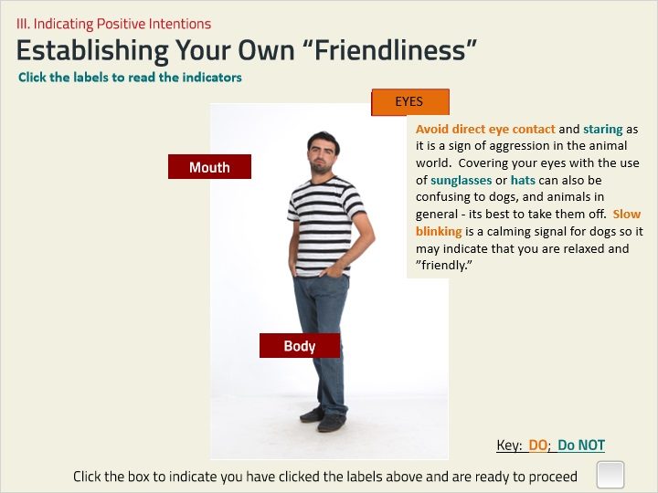

## 1.15 Summary of Step 1: Assessing from Afar

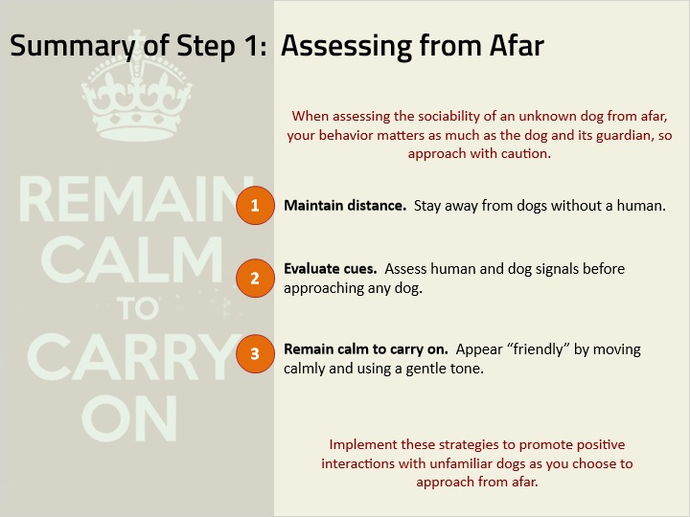

**Notes:**

## 1.16 Check-In

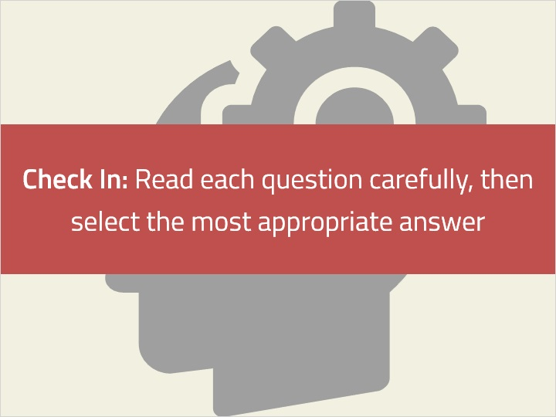

**Notes:**

## 1.17 Quiz 1A) What should you do if you see a dog that appears to be a service dog?

*(Multiple Choice, 10 points, 1 attempt permitted)*

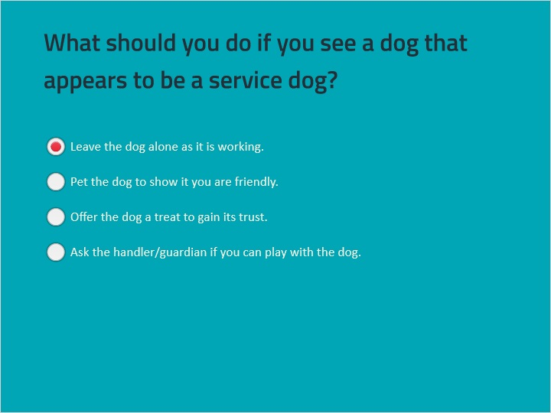

| Correct | Choice | Feedback |
| --- | --- | --- |
| Leave the dog alone as it is working. | X | Service dogs are trained to assist their handlers and should not be distracted while they are working. |
| Pet the dog to show it you are friendly. |  | Petting a service dog can distract it from its duties. |
| Offer the dog a treat to gain its trust. |  | Offering treats can distract a service dog and interfere with its training and duties. |
| Ask the handler/guardian if you can play with the dog. |  | Even asking to play with a service dog can be disruptive and is generally discouraged. |

### Ask the handler/guardian if you can play with the dog. (Slide Layer)

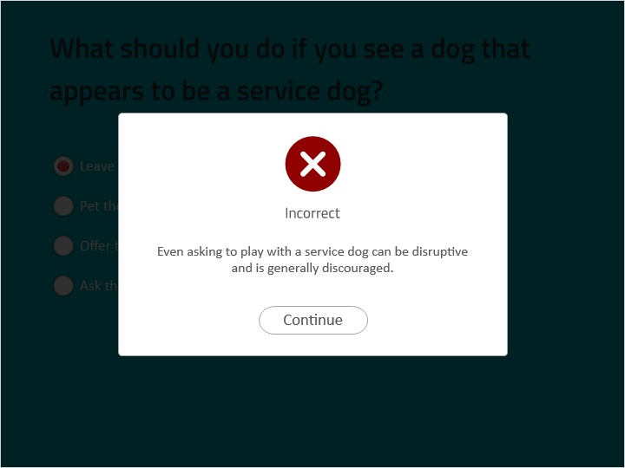

### Offer the dog a treat to gain its trust. (Slide Layer)

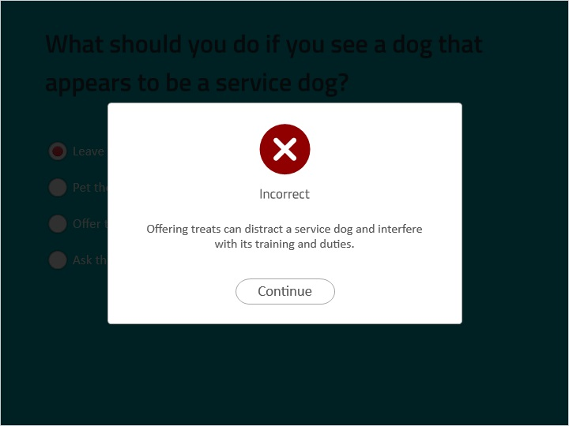

### Pet the dog to show it you are friendly. (Slide Layer)

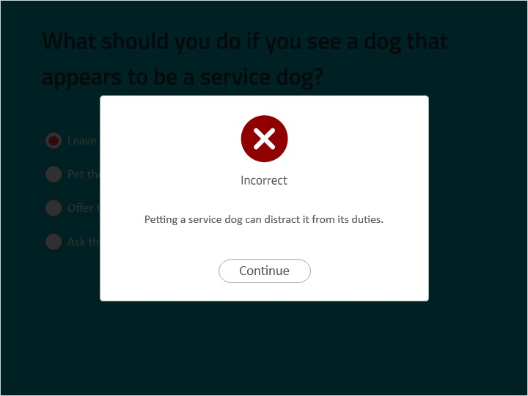

### Leave the dog alone as it is working. (Slide Layer)

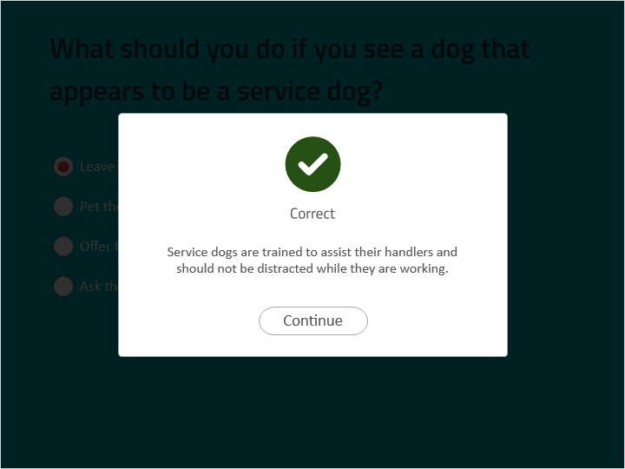

## 1.18 Quiz 1B) When is it NOT safe to approach a dog?

*(Multiple Choice, 10 points, 1 attempt permitted)*

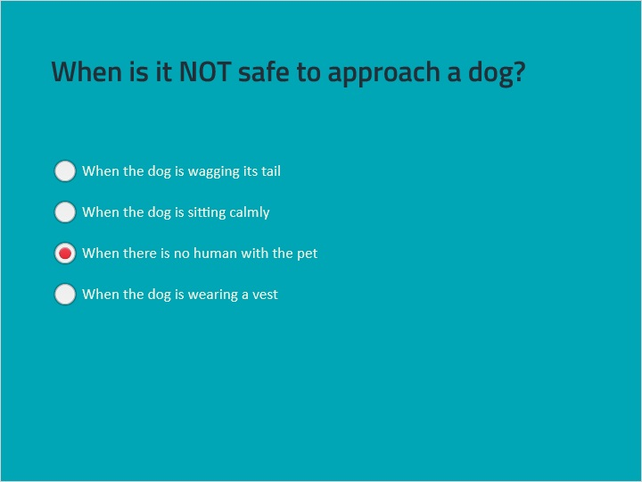

| Correct | Choice | Feedback |
| --- | --- | --- |
| When the dog is wagging its tail |  | Tail wagging can indicate various emotions, including friendliness and nervousness, but it does not address the safety concern of a dog without a human. |
| When the dog is sitting calmly |  | A calm demeanor may show the dog is “friendly” but it does not necessarily indicate it is safe to approach, especially if there is no human present. |
| When there is no human with the pet | X | Approaching a dog without a human present is unsafe as there is no one to control or communicate the dog's behavior. |
| When the dog is wearing a vest |  | While a vest may indicate the dog is a service animal or has specific needs, it does not necessarily mean it is unsafe to approach. |

### When the dog is wearing a vest (Slide Layer)

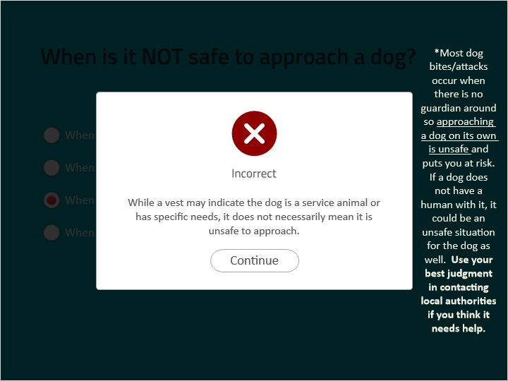

### When there is no human with the pet (Slide Layer)

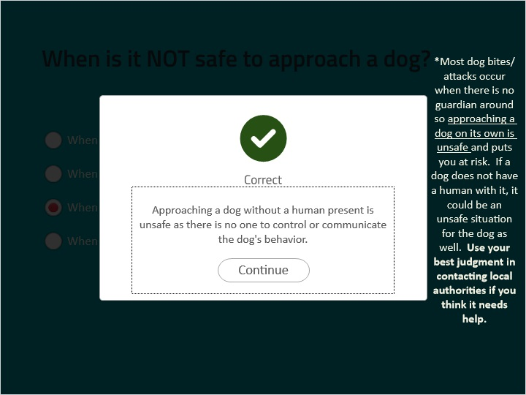

### When the dog is sitting calmly (Slide Layer)

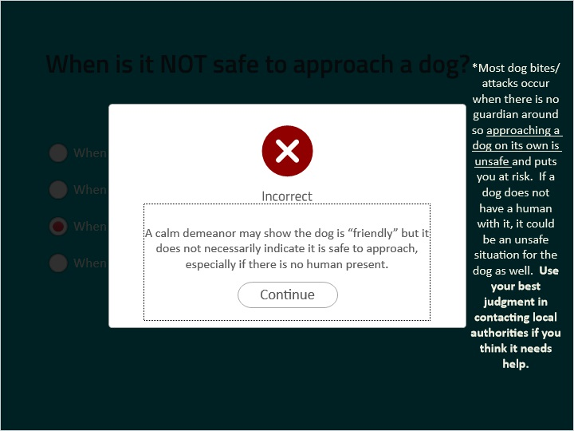

### When the dog is wagging its tail (Slide Layer)

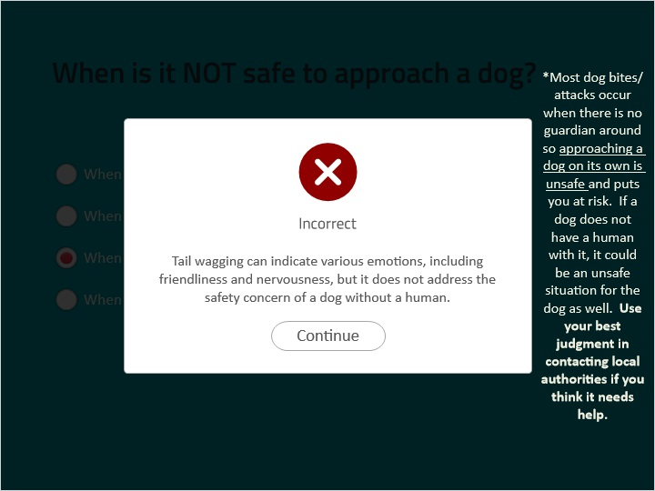

## 1.19 Quiz 1C) What should you DO to indicate your sociability to a dog?

*(Multiple Choice, 10 points, 1 attempt permitted)*

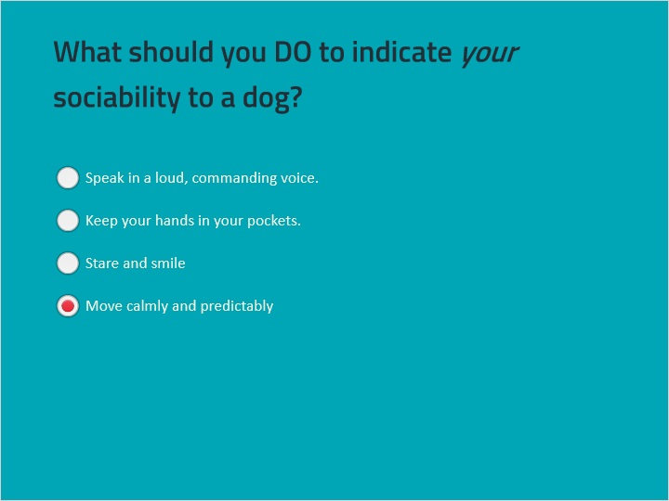

| Correct | Choice | Feedback |
| --- | --- | --- |
| Speak in a loud, commanding voice. |  | Speaking in a loud voice can be perceived as aggressive, particularly as dogs have sensitive hearing. Remaining calm and relaxed will best indicate your “friendliness.” |
| Keep your hands in your pockets. |  | Keeping hands in pockets should not impact your approach on the dog but it does not indicate your “friendliness,” like remaining calm and relaxed can. |
| Stare and smile |  | Direct eye contact and staring are perceived as signs of aggression by dogs. Moving calmly and predictably is a better indicator of your “friendliness.” |
| Move calmly and predictably | X | Moving quickly and unpredictably can scare a dog, it does not indicate you are “friendly.” Remaining relaxed helps a dog to relax around you and indicates your positive sociability. |

### Move calmly and predictably (Slide Layer)

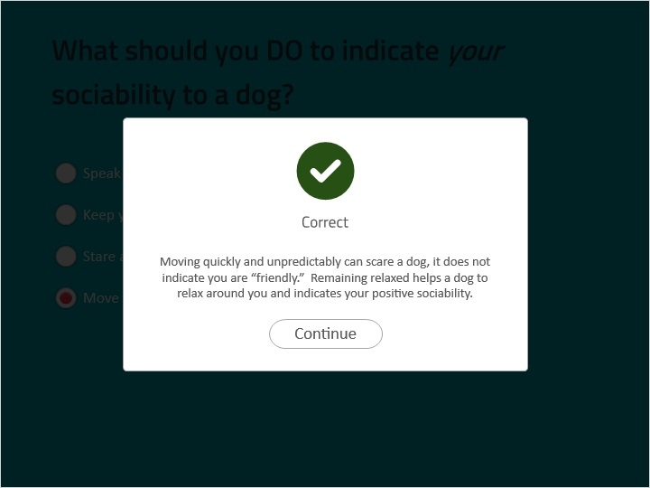

### Stare and smile (Slide Layer)

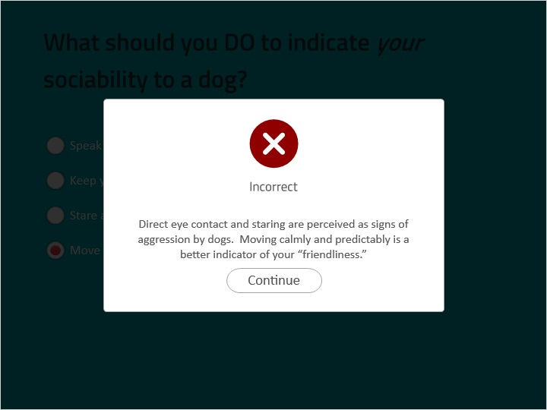

### Keep your hands in your pockets. (Slide Layer)

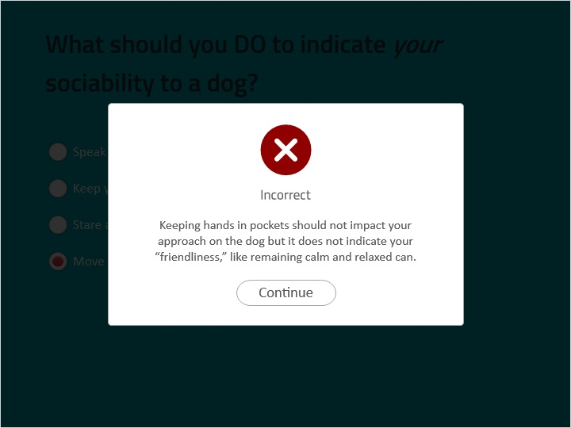

### Speak in a loud, commanding voice. (Slide Layer)

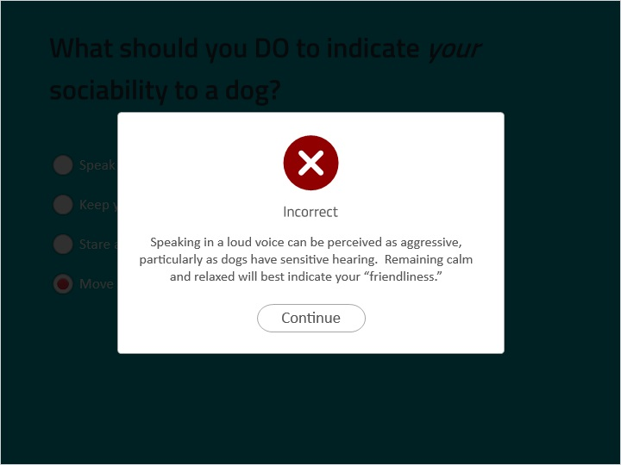

## 1.20 Quiz 1D) What does it indicate if a dog's tail is tucked under?

*(Multiple Choice, 10 points, 1 attempt permitted)*

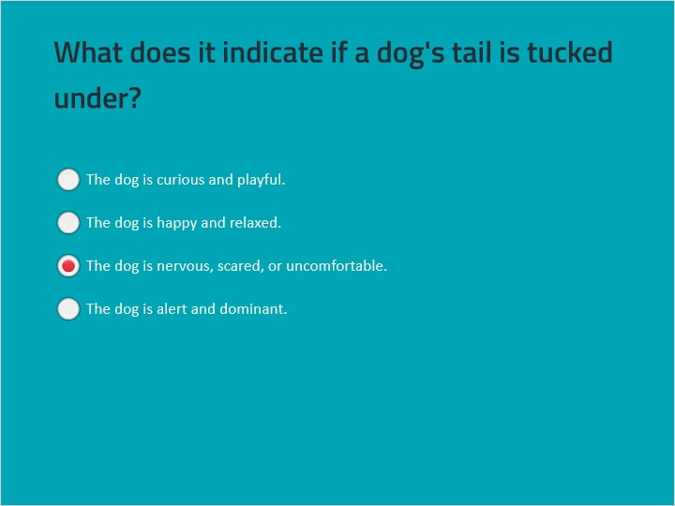

| Correct | Choice | Feedback |
| --- | --- | --- |
| The dog is curious and playful. |  | This is incorrect because a tucked tail does not indicate curiosity or playfulness – it indicates that the dog is nervous or scared. |
| The dog is happy and relaxed. |  | This is incorrect because a tucked tail does not indicate happiness or relaxation – it indicates that the dog is nervous or scared. |
| The dog is nervous, scared, or uncomfortable. | X | A tucked tail is a clear signal that the dog is feeling nervous, scared, or uncomfortable. |
| The dog is alert and dominant. |  | This is incorrect because a tucked tail does not indicate alertness or dominance – it indicates that the dog is nervous or scared. |

### The dog is alert and dominant. (Slide Layer)

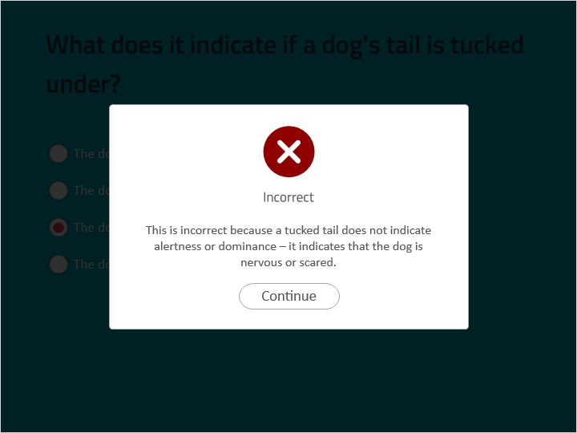

### The dog is nervous, scared, or uncomfortable. (Slide Layer)

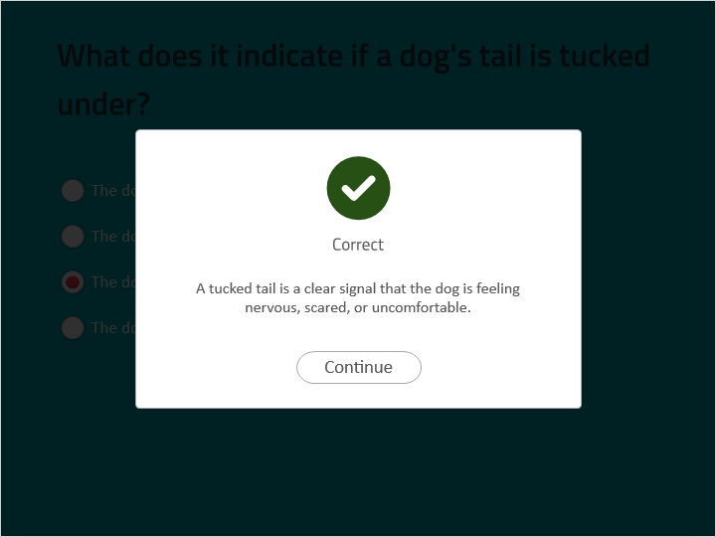

### The dog is happy and relaxed. (Slide Layer)

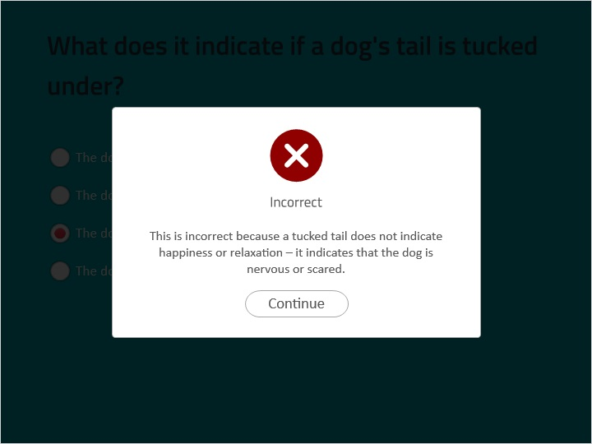

### The dog is curious and playful. (Slide Layer)

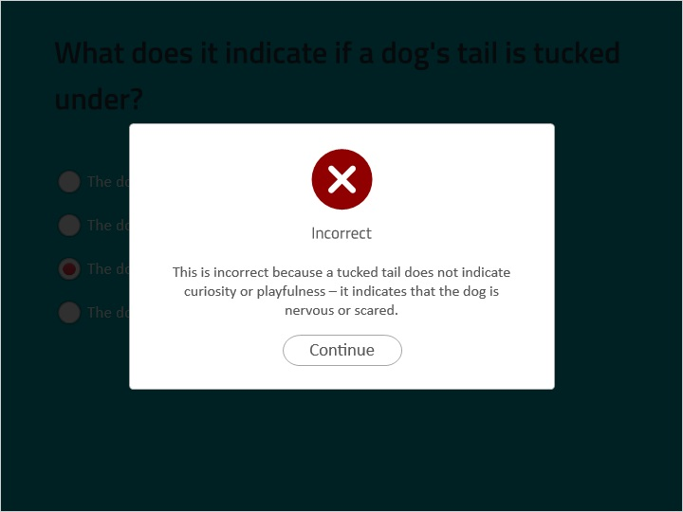

## 1.21 Section 1 Celebration

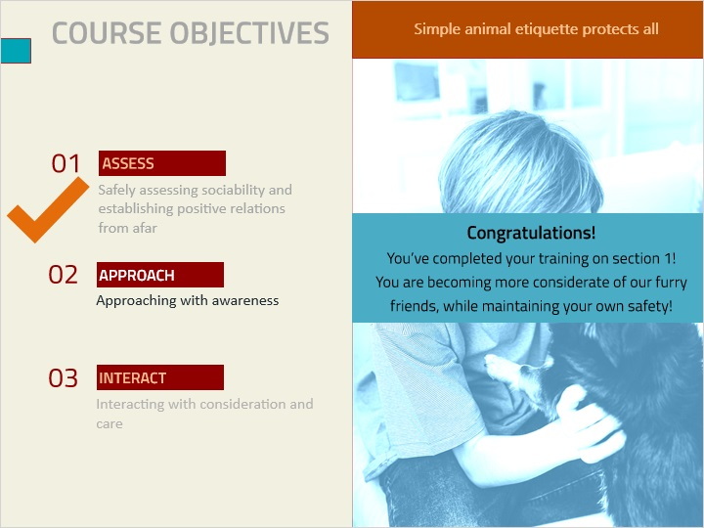

**Notes:**

## 1.22 Step 2: Approach

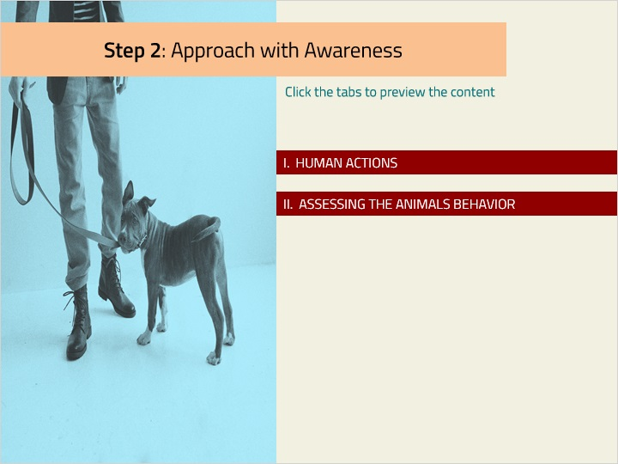

### Tab 01 (Slide Layer)

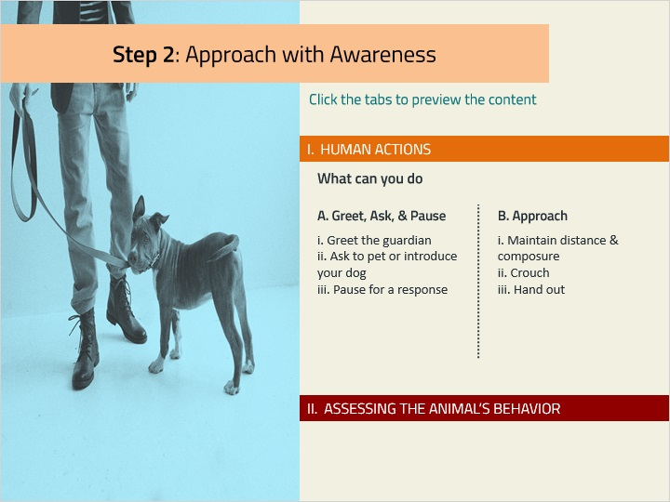

### Tab 02 (Slide Layer)

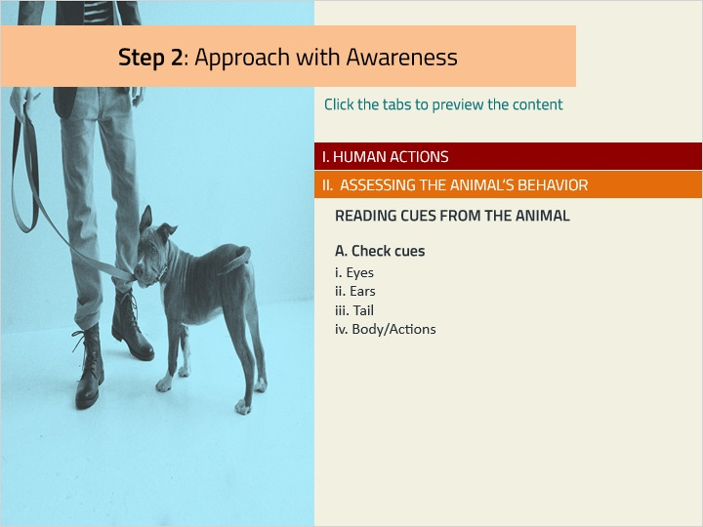

## 1.23 Approach with Awareness

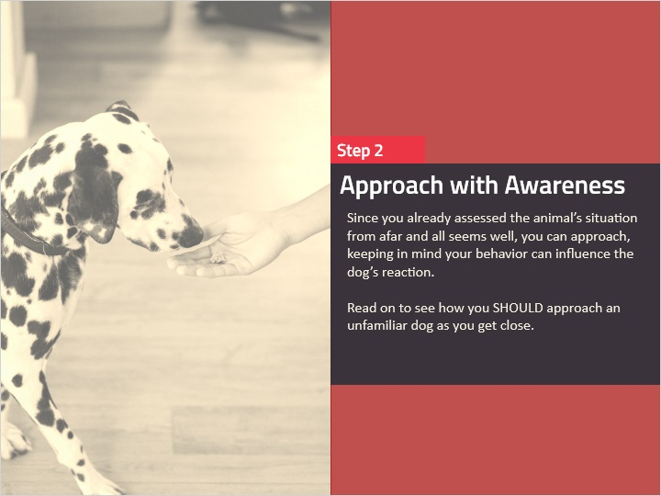

**Notes:**

## 1.24 I. Approach with Awareness

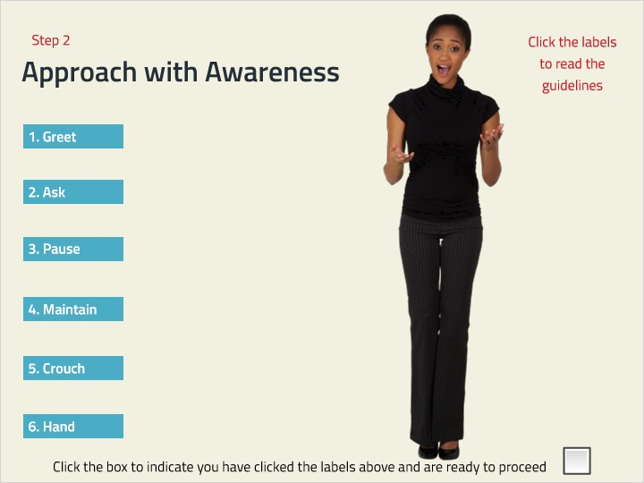

**Notes:**

### Untitled Layer 6 (Slide Layer)

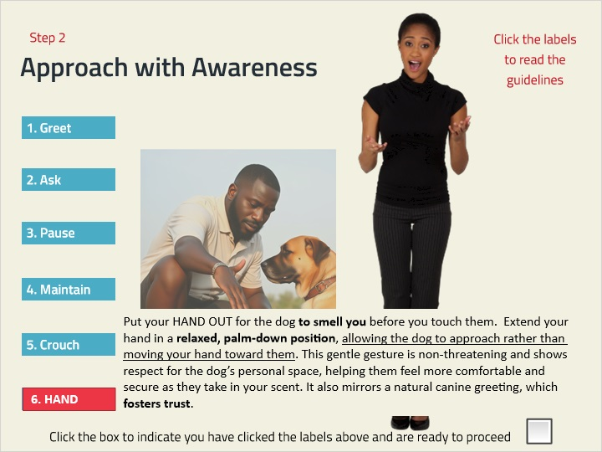

### Untitled Layer 5 (Slide Layer)

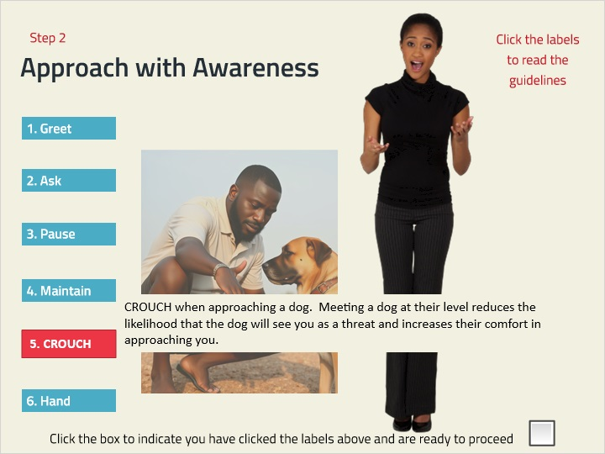

### Untitled Layer 4 (Slide Layer)

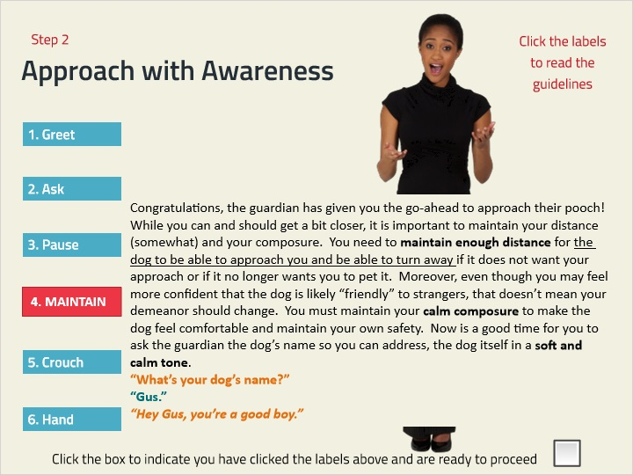

### Untitled Layer 3 (Slide Layer)

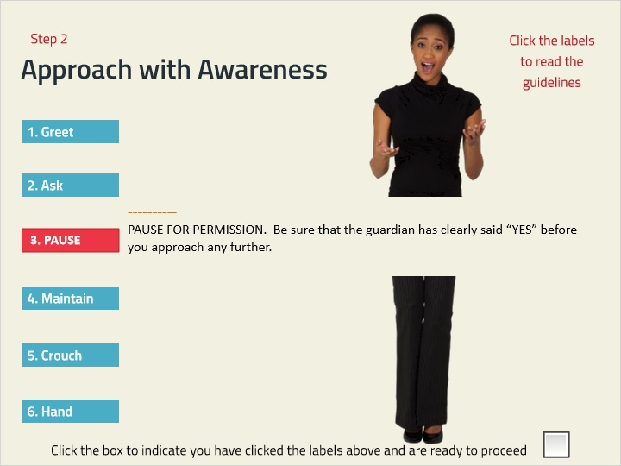

### Untitled Layer 2 (Slide Layer)

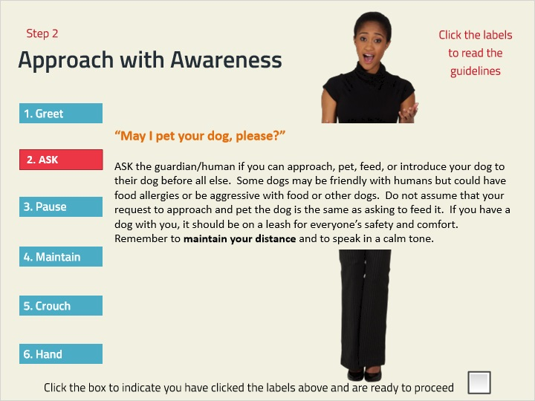

### Untitled Layer 1 (Slide Layer)

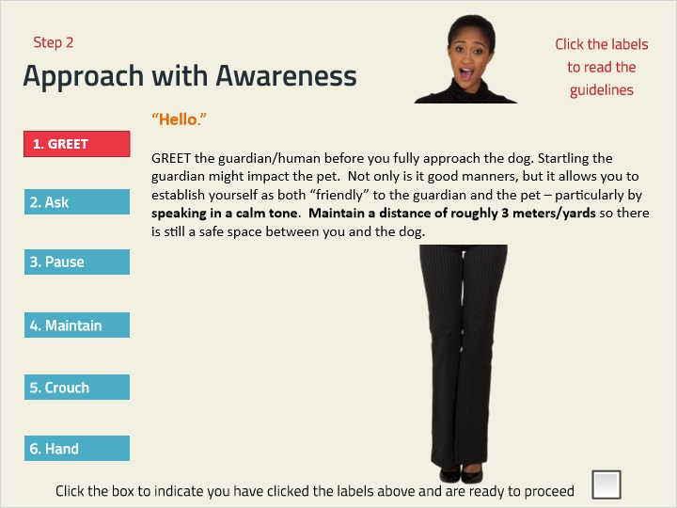

## 1.25 II. Reassessing the Dog's Cues

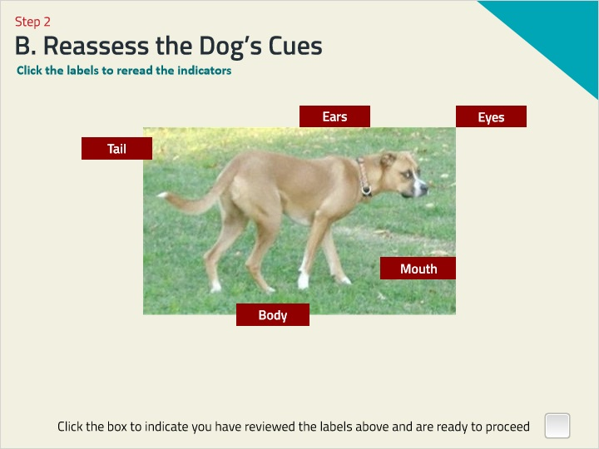

**Notes:**

### Untitled Layer 5 (Slide Layer)

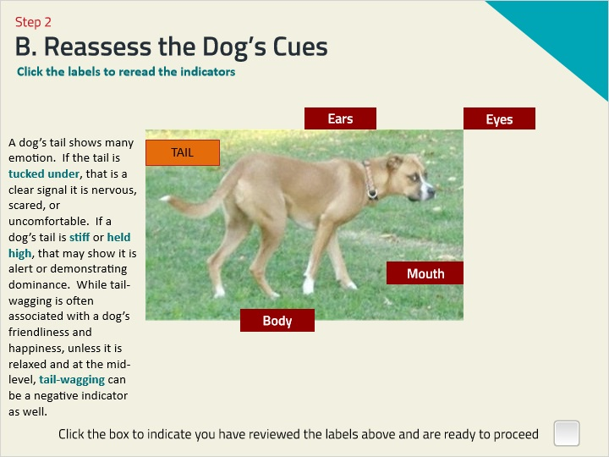

### Untitled Layer 4 (Slide Layer)

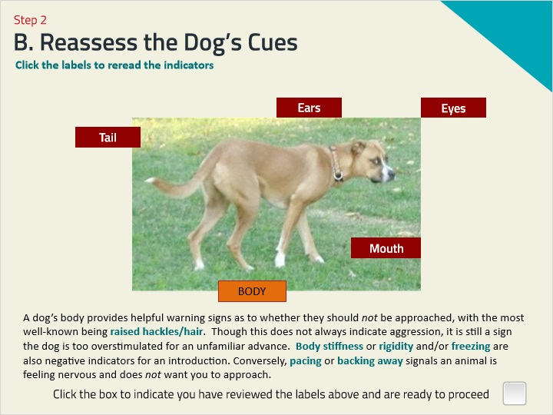

### Untitled Layer 3 (Slide Layer)

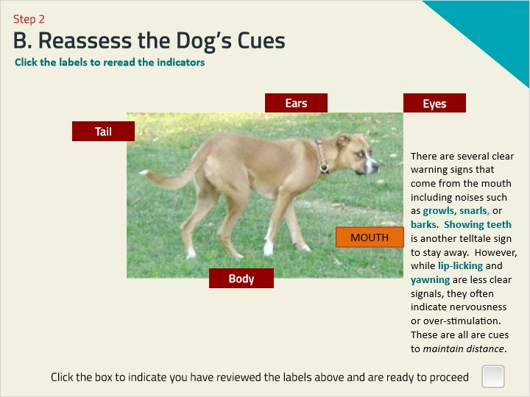

### Untitled Layer 2 (Slide Layer)

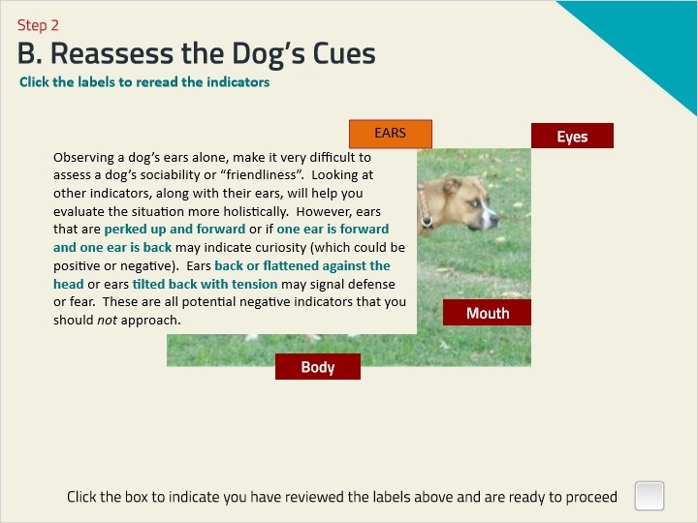

### Untitled Layer 1 (Slide Layer)

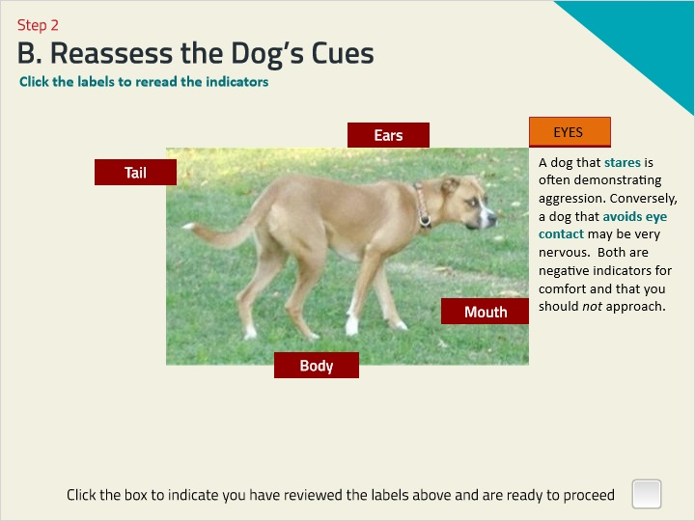

## 1.26 Summary of Step 2: Approaching with Awareness

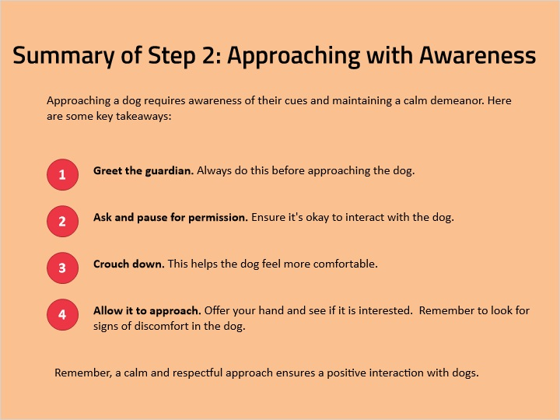

## 1.27 DRAG-AND-DROP INTERACTION

*(Drag and Drop, 10 points, 2 attempts permitted)*

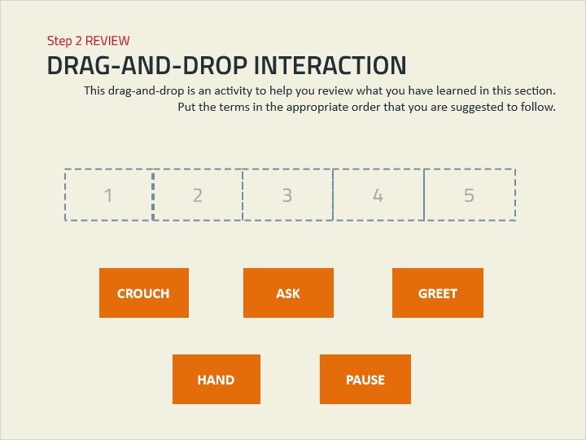

| Drag Item | Drop Target |
| --- | --- |
| GREET | 1 |
| ASK | 2 |
| PAUSE | 3 |
| CROUCH | 4 |
| HAND | 5 |

| Drag and drop properties |
| --- |
| Snap dropped items to drop target (Snap to center) |
| Allow only one item in each drop target |
| Delay item drop states until interaction is submitted |

**Feedback when correct:**

That's right! You selected the correct response.

**Feedback when incorrect:**

You did not select the correct response.

**Notes:**

### Try Again (Slide Layer)

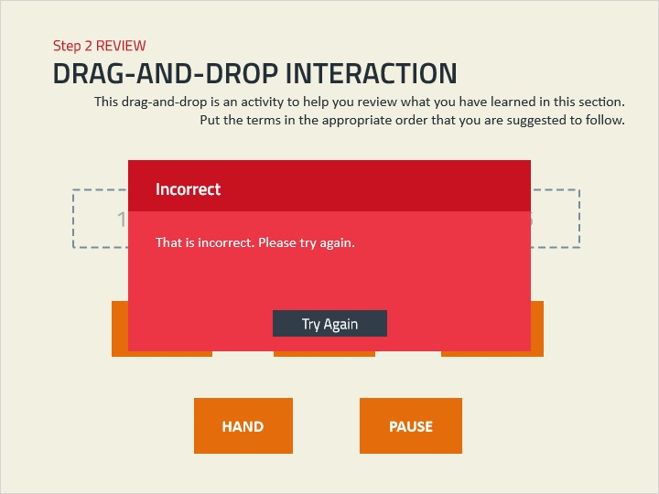

### Incorrect (Slide Layer)

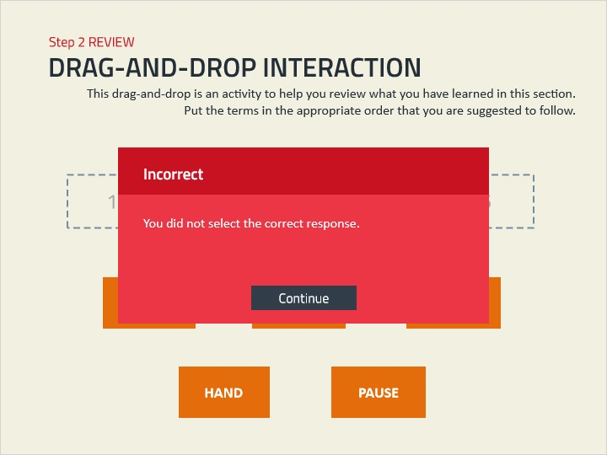

### Correct (Slide Layer)

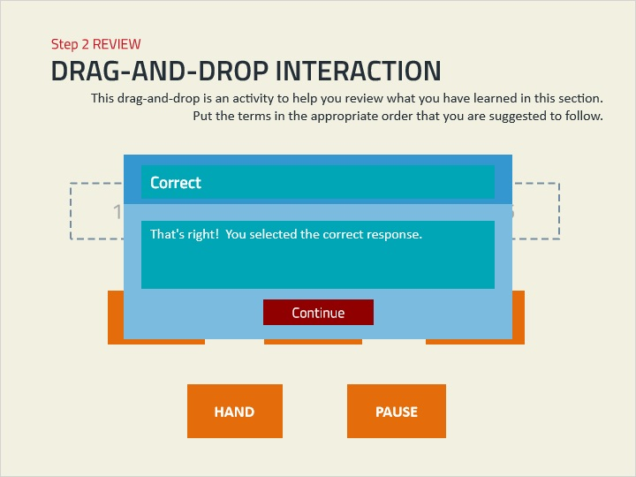

## 1.28 DRAG-AND-DROP INTERACTION

*(Drag and Drop, 0 points, 2 attempts permitted)*

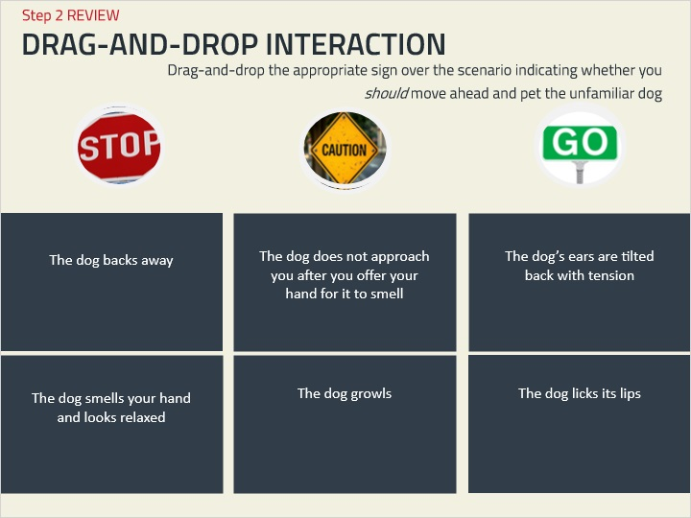

| Drag Item | Drop Target |
| --- | --- |
| Drag Item 01 9 | Drop Target 01 |
| Drag Item 01 8 | Drop Target 02 |
| Drag Item 01 6 | Drop Target 03 |
| Drag Item 01 2 | Drop Target 04 |
| Drag Item 01 1 | Drop Target 01 1 |
| Drag Item 01 | Drop Target 01 2 |
| Drag Item 01 11 |  |
| Drag Item 01 12 |  |
| Drag Item 01 13 |  |
| Drag Item 01 4 |  |
| Drag Item 01 10 |  |
| Drag Item 01 5 |  |
| Drag Item 01 3 |  |
| Drag Item 01 7 |  |
| Drag Item 01 14 |  |
| Drag Item 01 15 |  |
| Drag Item 01 16 |  |
| Drag Item 01 17 |  |

| Drag and drop properties |
| --- |
| Snap dropped items to drop target (Stack random) |
| Delay item drop states until interaction is submitted |

**Notes:**

## 1.29 Drag and Drop Key

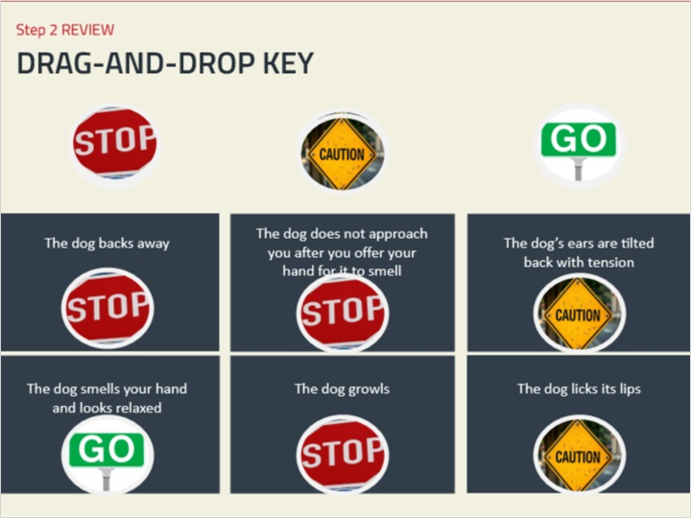

## 1.30 Section 2 Celebration

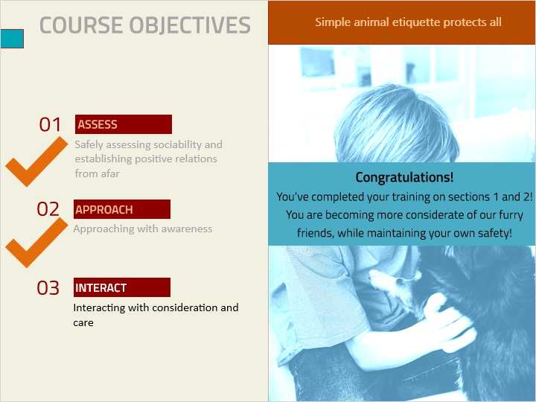

**Notes:**

## 1.31 Step 3: Interacting with Care

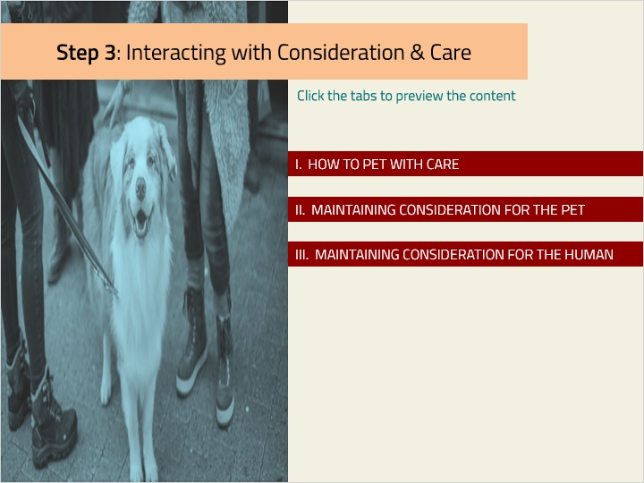

### Tab 03 (Slide Layer)

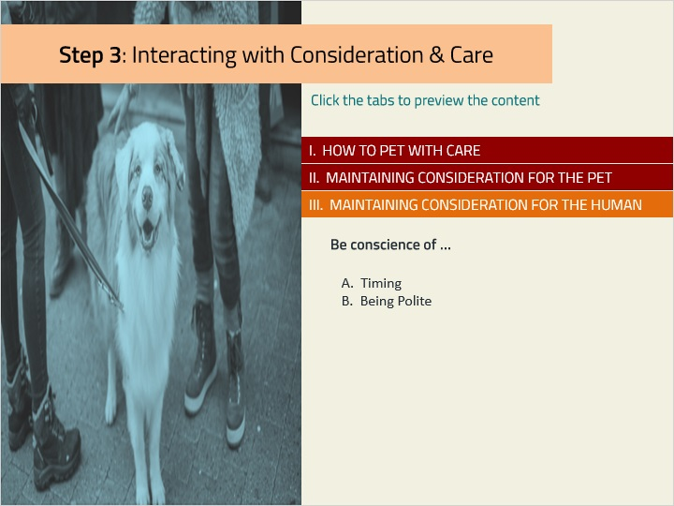

### Tab 02 (Slide Layer)

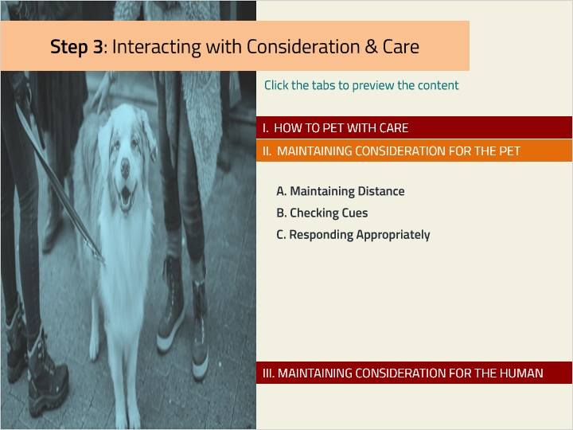

### Tab 01 (Slide Layer)

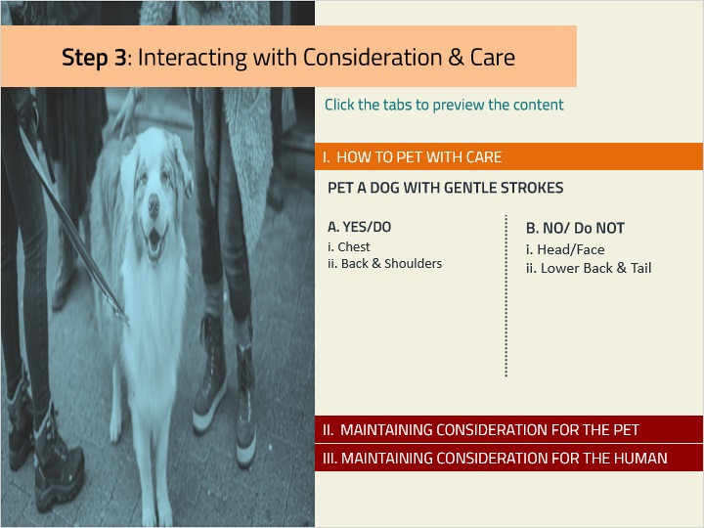

## 1.32 Interacting with Consideration & Care

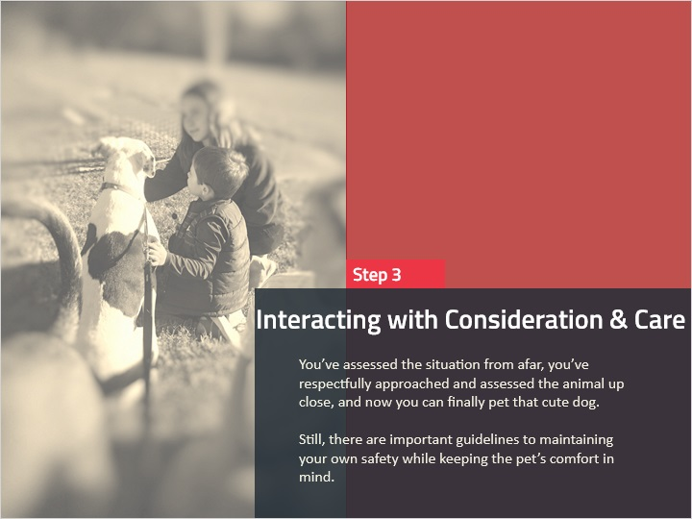

**Notes:**

## 1.33 How to Pet

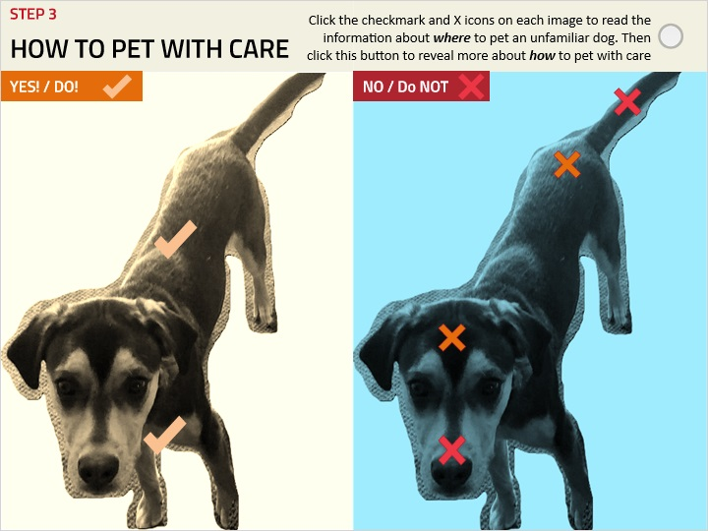

### Untitled Layer 5 (Slide Layer)

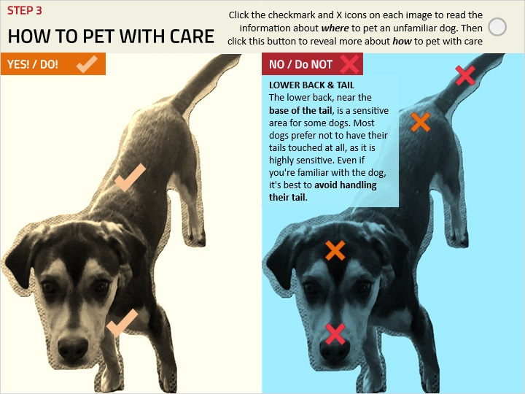

### Untitled Layer 4 (Slide Layer)

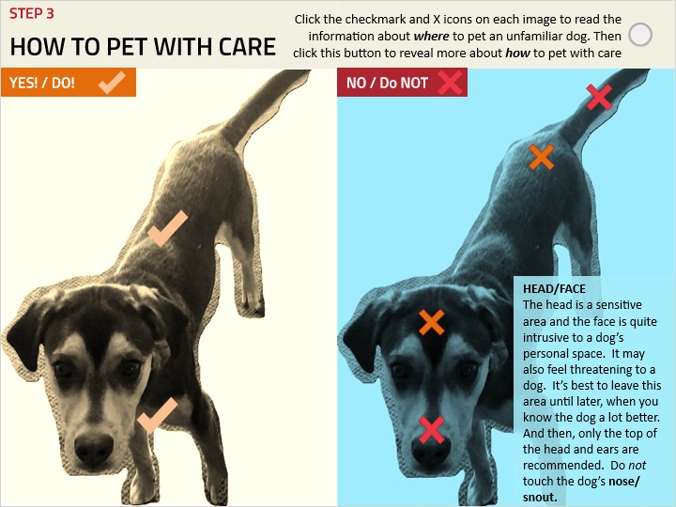

### Untitled Layer 3 (Slide Layer)

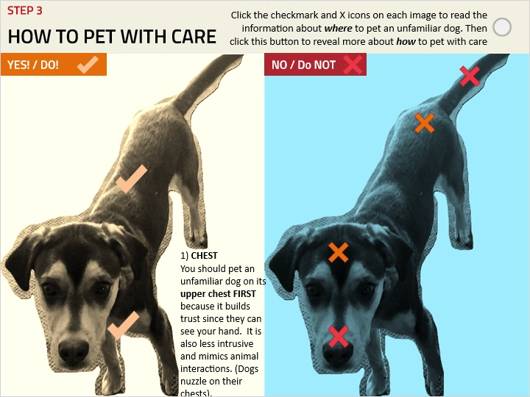

### Untitled Layer 2 (Slide Layer)

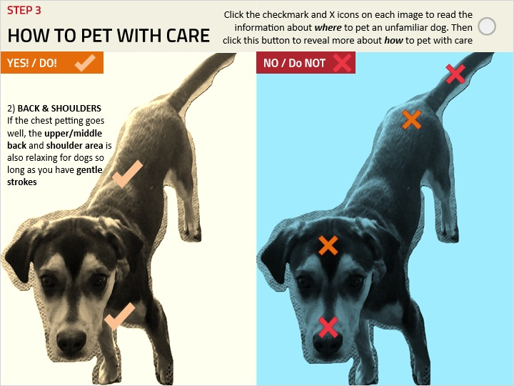

### Untitled Layer 1 (Slide Layer)

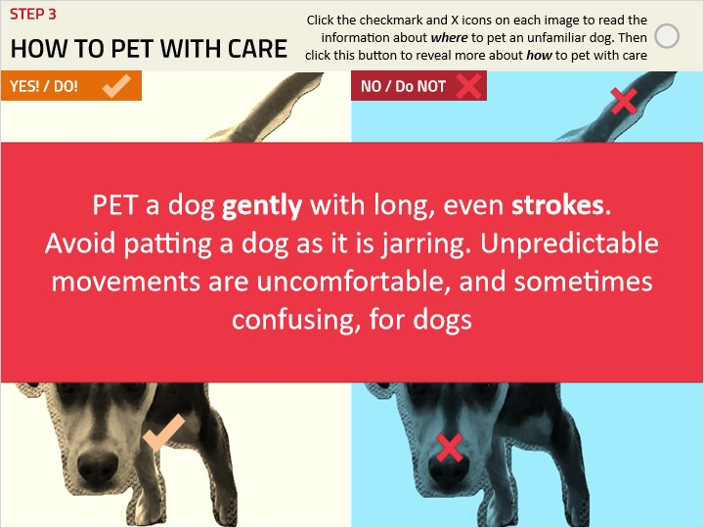

## 1.34 II. Maintaining Consideration & Responding to Cues

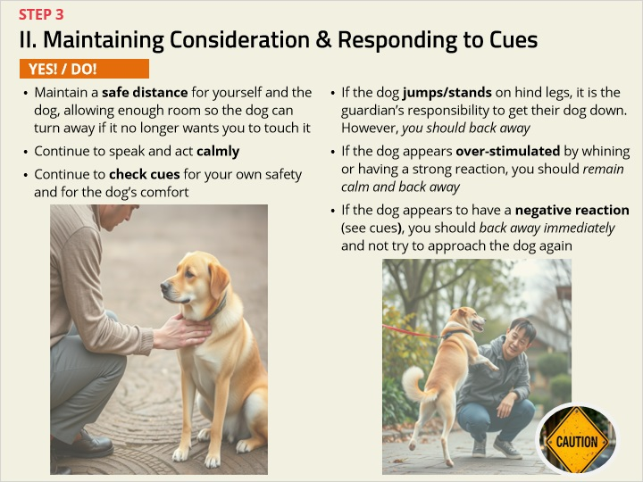

## 1.35 III. Maintaining Consideration for the Human

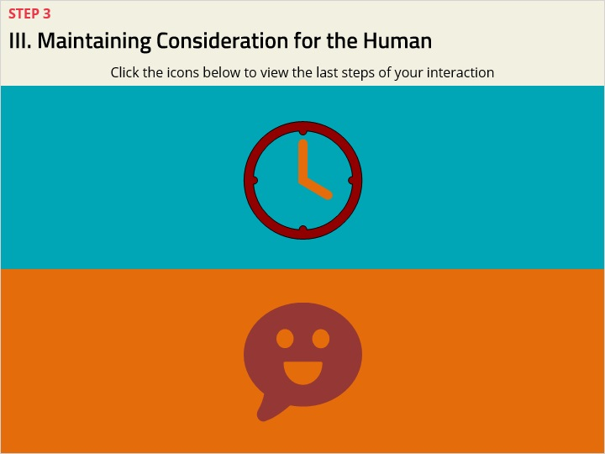

### Untitled Layer 2 (Slide Layer)

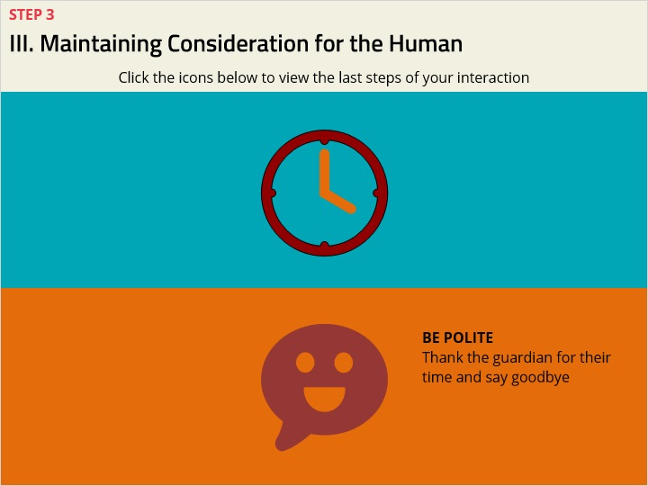

### Untitled Layer 1 (Slide Layer)

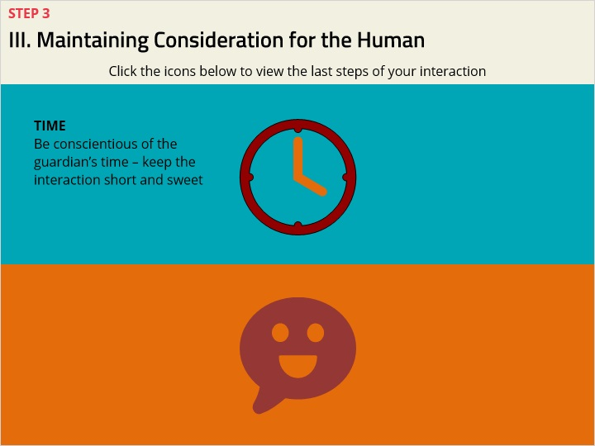

## 1.36 Summary of Step 3: Petting with Consideration & Care

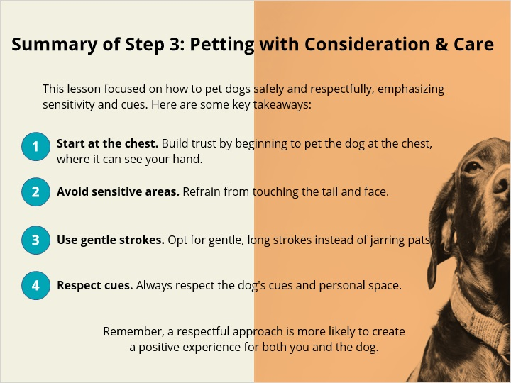

## 1.37 DRAG-AND-DROP INTERACTION

*(Drag and Drop, 10 points, 2 attempts permitted)*

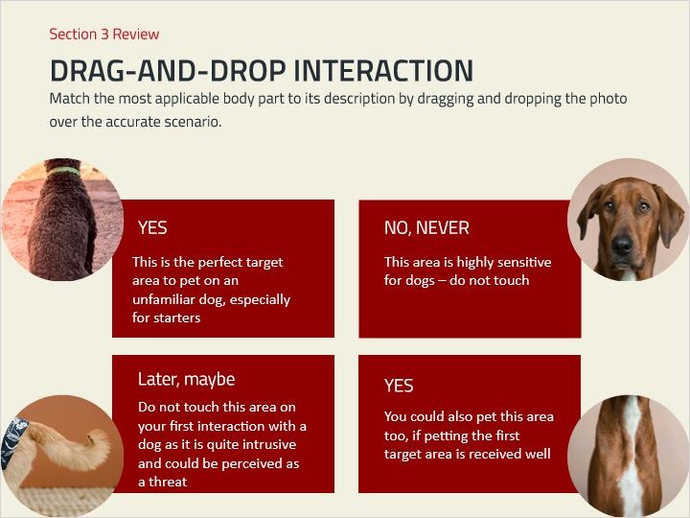

| Drag Item | Drop Target |
| --- | --- |
| Picture 1 | Drop Target 01 |
| Picture 3 | Drop Target 02 |
| Picture 2 | Drop Target 03 |
| Picture 4 | Drop Target 04 |

| Drag and drop properties |
| --- |
| Snap dropped items to drop target (Stack random) |
| Delay item drop states until interaction is submitted |

**Feedback when correct:**

That's right! You selected the correct response.

**Feedback when incorrect:**

You did not select the correct response.

**Notes:**

### Try Again (Slide Layer)

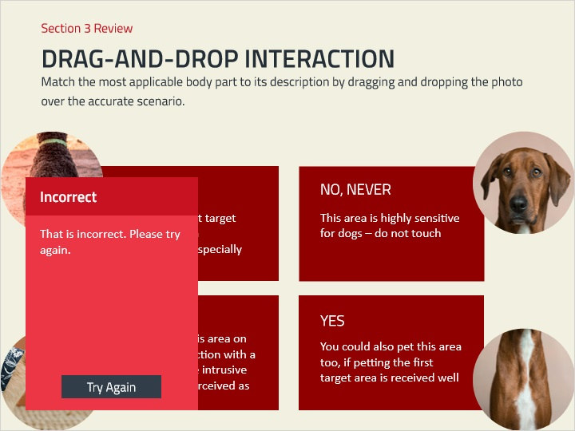

### Incorrect (Slide Layer)

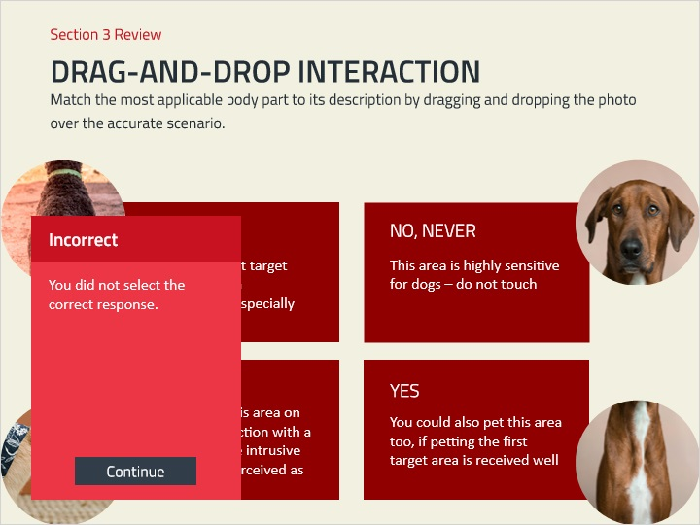

### Correct (Slide Layer)

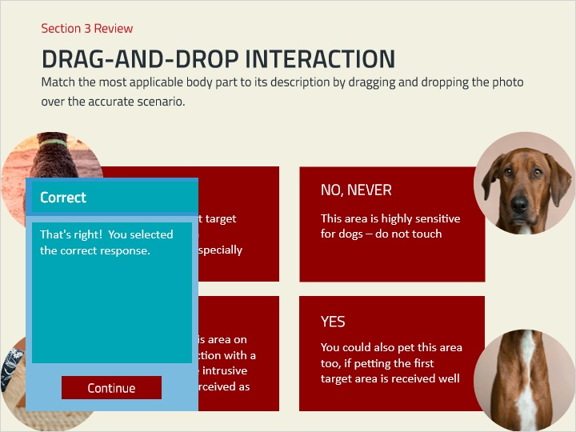

## 1.38 Post Self-Assessment

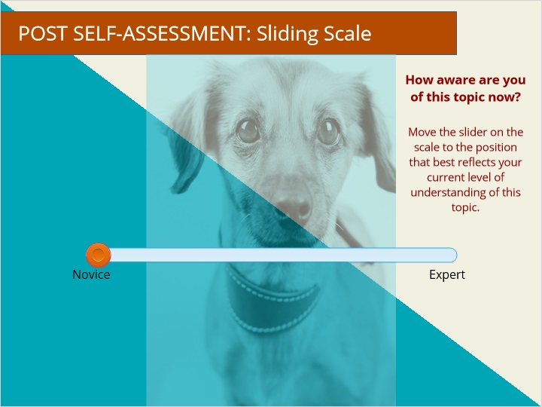

## 1.39 Assessment

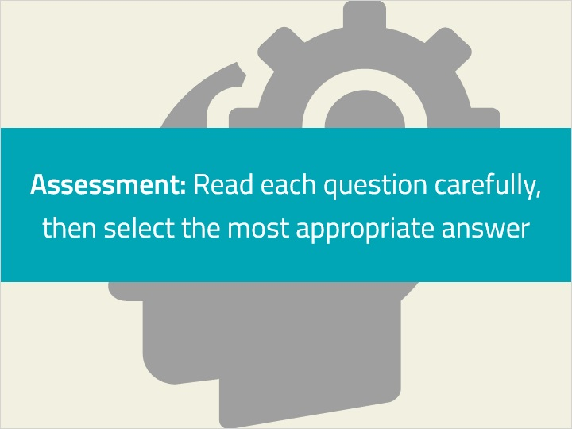

**Notes:**

## 1.40 Quiz 2A) A dog wagging its tail is always positive

*(Multiple Choice, 10 points, 1 attempt permitted)*

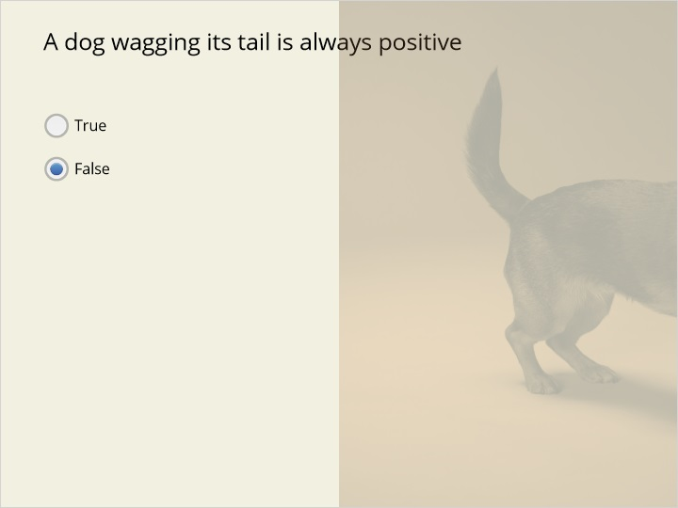

| Correct | Choice | Feedback |
| --- | --- | --- |
| True |  | Tail-wagging can signal a variety or emotions in a dog |
| False | X | Tail-wagging can signal a variety or emotions in a dog |

**Notes:**

### False (Slide Layer)

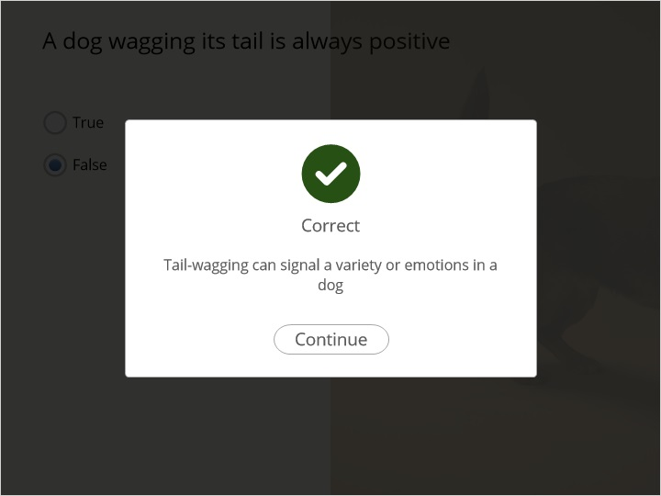

### True (Slide Layer)

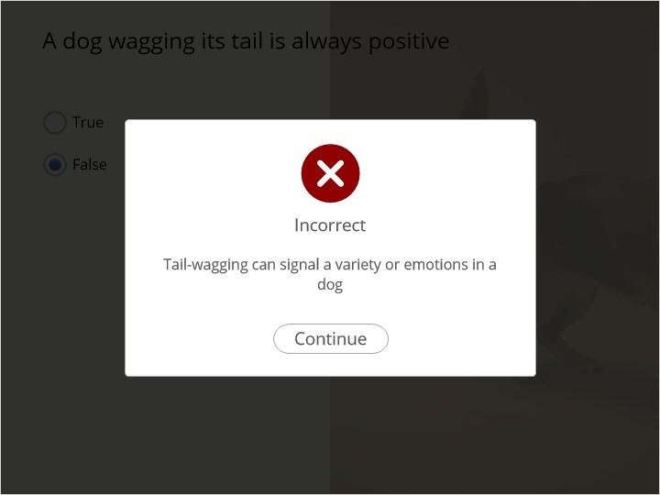

## 1.41 Quiz 2B) What should you do if a dog appears over-stimulated by whining or having a strong reaction?

*(Multiple Choice, 10 points, 1 attempt permitted)*

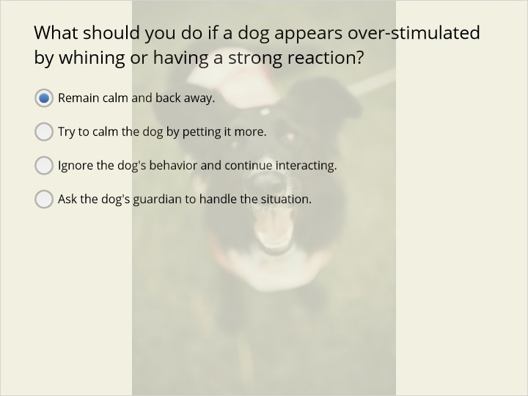

| Correct | Choice | Feedback |
| --- | --- | --- |
| Remain calm and back away. | X | This is the correct response to ensure both the dog's comfort and your safety. |
| Try to calm the dog by petting it more. |  | This answer is incorrect as it could further agitate the dog. You should remain calm and back away. |
| Ignore the dog's behavior and continue interacting. |  | This answer is incorrect as ignoring the dog's signs of discomfort can lead to negative outcomes. You should remain calm and back away. |
| Ask the dog's guardian to handle the situation. |  | While involving the guardian might be helpful, the immediate response should be to back away. |

### Ask the dog's guardian to handle the situation. (Slide Layer)

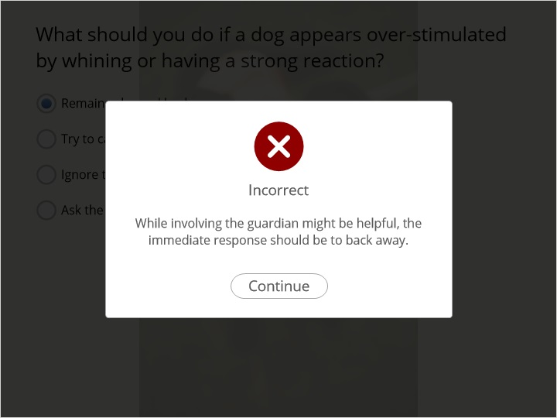

### Ignore the dog's behavior and continue interacting. (Slide Layer)

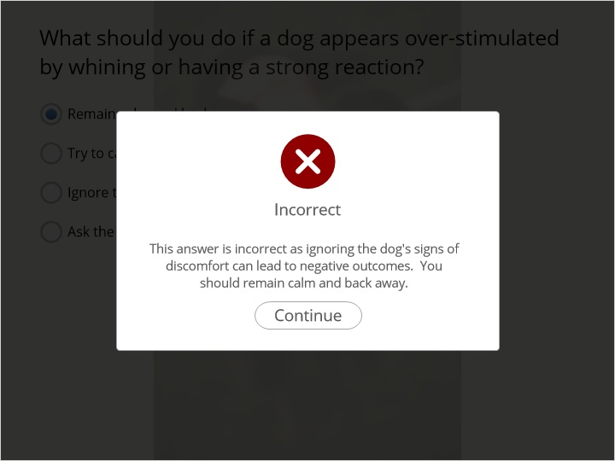

### Try to calm the dog by petting it more. (Slide Layer)

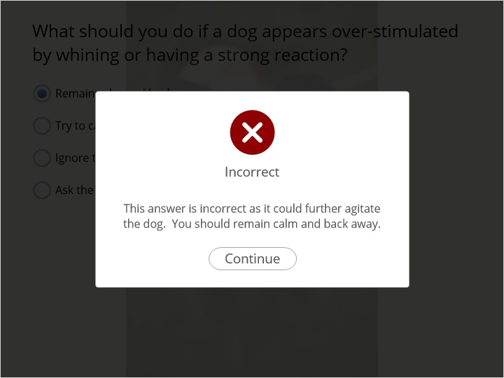

### Remain calm and back away. (Slide Layer)

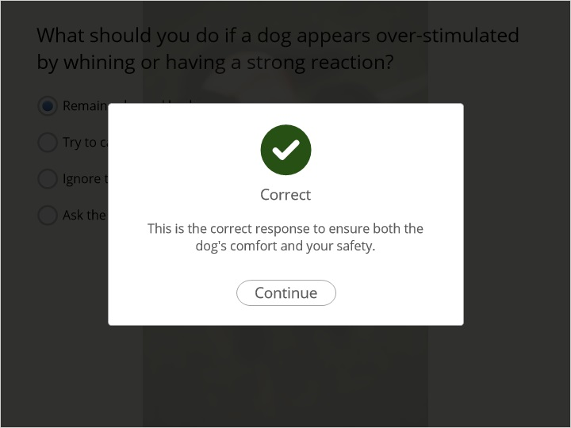

## 1.42 Quiz 2C) Directly after you ask a guardian if you can pet their dog

*(Multiple Choice, 10 points, 1 attempt permitted)*

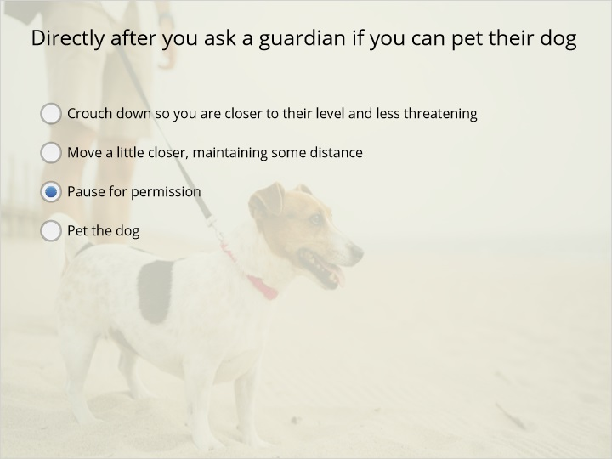

| Correct | Choice | Feedback |
| --- | --- | --- |
| Crouch down so you are closer to their level and less threatening |  | The order is: Ask, pause for permission, crouch down, offer your hand, then pet |
| Move a little closer, maintaining some distance |  | You need to pause for the guardian’s permission before you move any closer |
| Pause for permission | X | Pausing for the guardian’s permission is absolutely necessary before any next steps. |
| Pet the dog |  | The order is: Ask, pause for permission, crouch down, offer your hand, then pet |

### Pet the dog (Slide Layer)

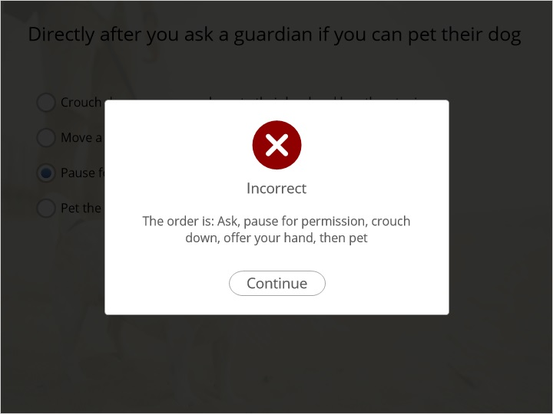

### Pause for permission (Slide Layer)

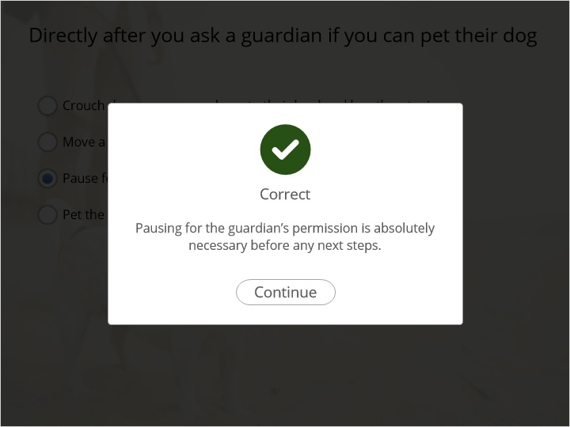

### Move a little closer, maintaining some distance (Slide Layer)

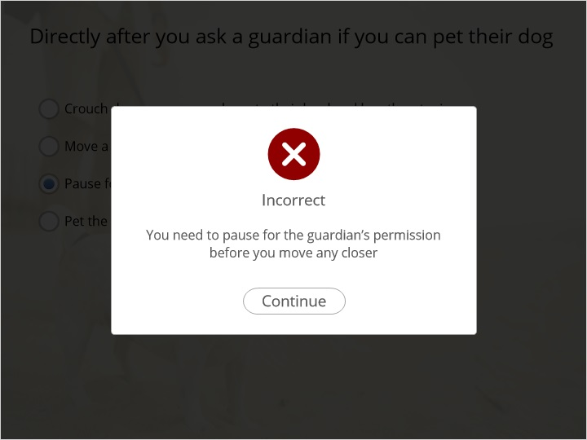

### Crouch down so you are closer to their level and less threatening (Slide Layer)



## 1.43 Quiz 2C) What is the proper way to offer your hand to a dog before touching them?

*(Multiple Choice, 10 points, 1 attempt permitted)*

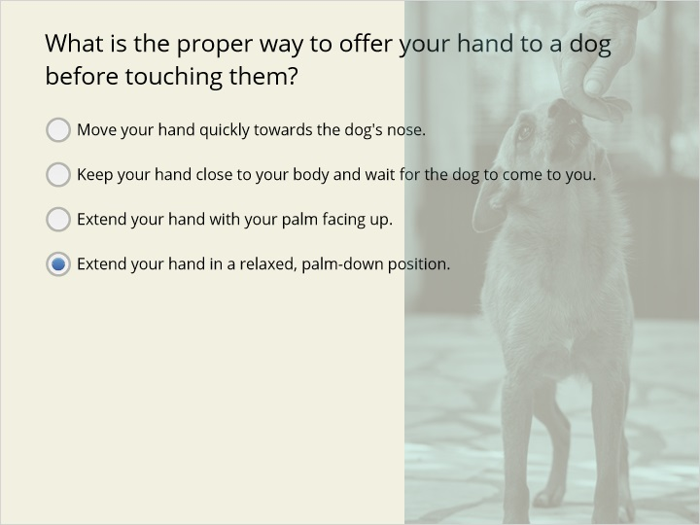

| Correct | Choice | Feedback |
| --- | --- | --- |
| Move your hand quickly towards the dog's nose. |  | This can startle the dog and make it feel threatened. Instead, extend your hand in a relaxed, palm-down position. |
| Keep your hand close to your body and wait for the dog to come to you. |  | While waiting for the dog to approach is correct, not extending your hand does not facilitate the dog's ability to smell you. |
| Extend your hand with your palm facing up. |  | This method can be perceived as more intrusive and less natural for the dog. With your palm up, they may also incorrectly think you are trying to feed it which may cause confusion |
| Extend your hand in a relaxed, palm-down position. | X | This is the correct method as it is non-threatening and respects the dog's personal space. |

### Extend your hand in a relaxed, palm-down position. (Slide Layer)

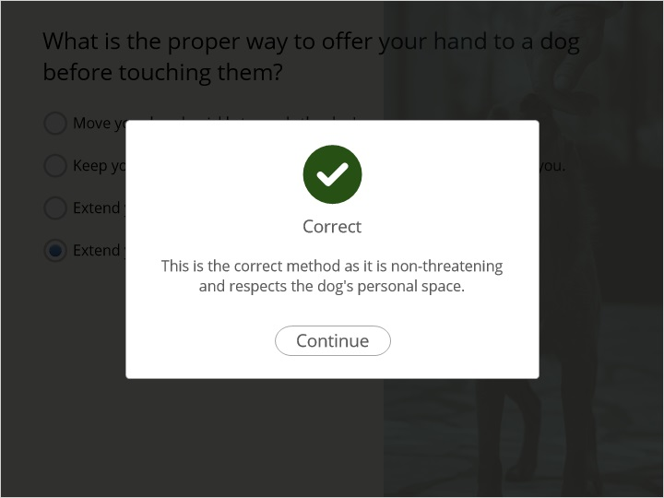

### Extend your hand with your palm facing up. (Slide Layer)

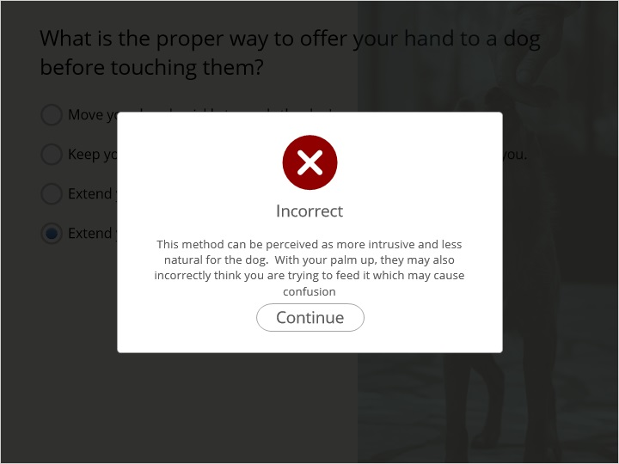

### Keep your hand close to your body and wait for the dog to come to you. (Slide Layer)

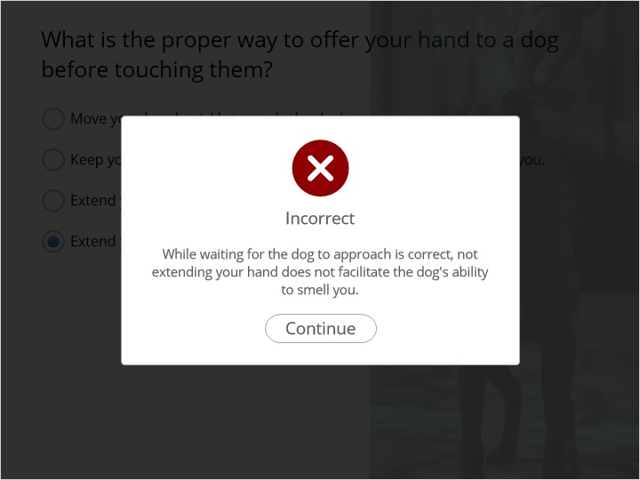

### Move your hand quickly towards the dog's nose. (Slide Layer)

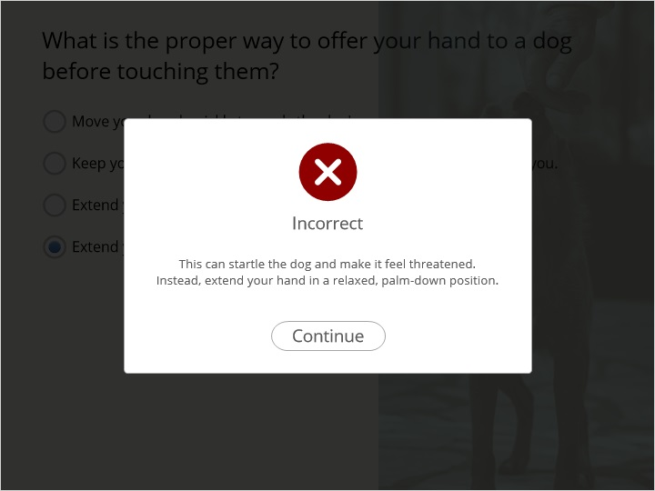

## 1.44 Quiz 2D) Why should you pet an unfamiliar dog on its upper chest first? (Choose all answers that are correct).

*(Multiple Response, 10 points, 1 attempt permitted)*

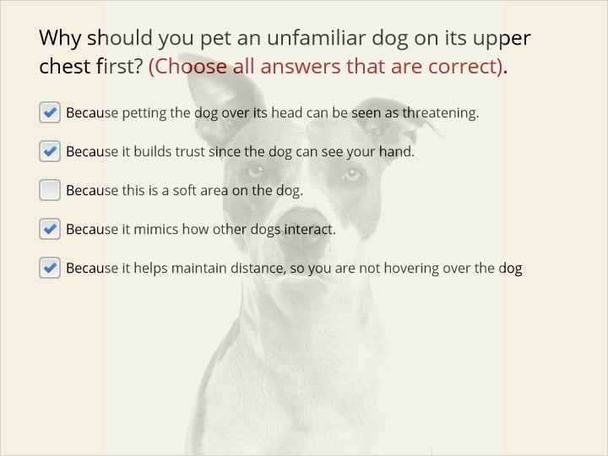

| Correct | Choice |
| --- | --- |
| Because petting the dog over its head can be seen as threatening. | X |
| Because it builds trust since the dog can see your hand. | X |
| Because this is a soft area on the dog. |  |
| Because it mimics how other dogs interact. | X |
| Because it helps maintain distance, so you are not hovering over the dog | X |

**Feedback when correct:**

Correct! Petting an unfamiliar dog on its upper chest helps build trust since the dog can see your hand.

**Feedback when incorrect:**

Incorrect. There are several correct answers.
Try this question again.

### Incorrect (Slide Layer)

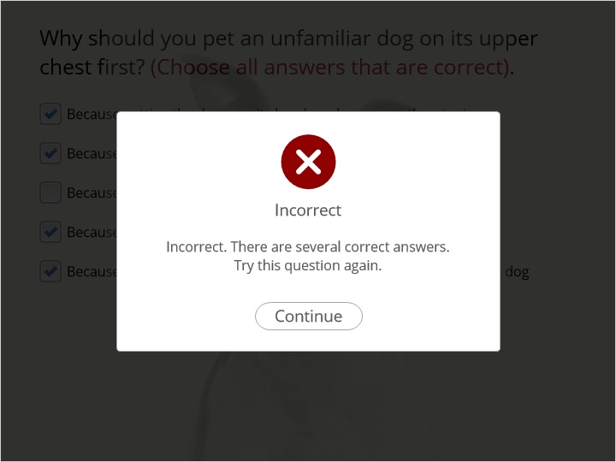

### Correct (Slide Layer)

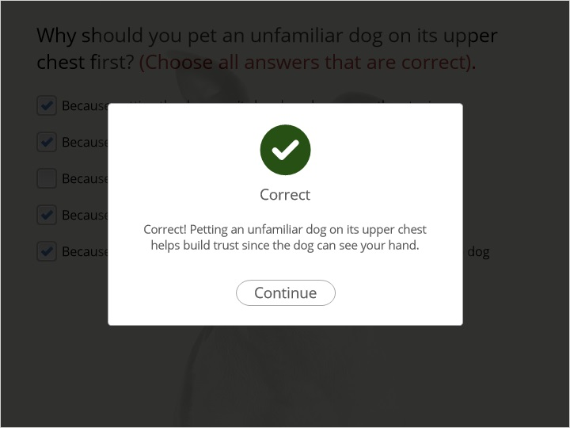

## 1.45 Jumping Scenario

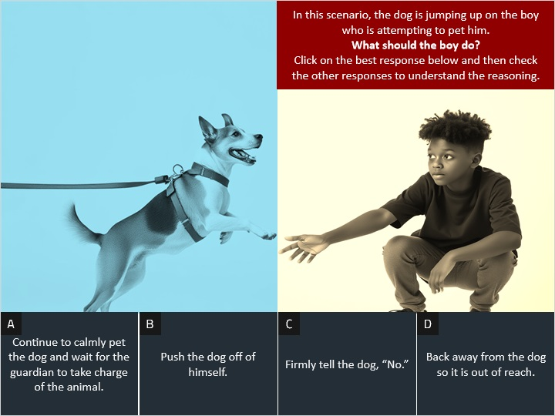

**Notes:**

### Consequence D (Slide Layer)

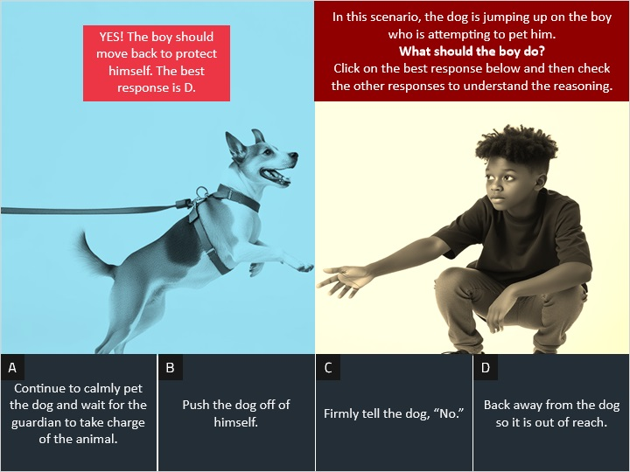

### Consequence C (Slide Layer)

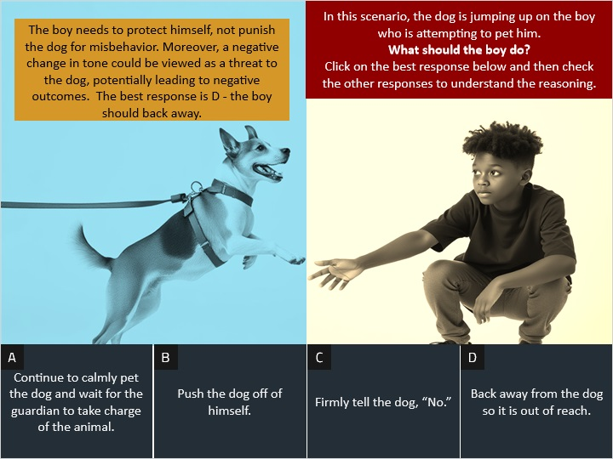

### Consequence B (Slide Layer)

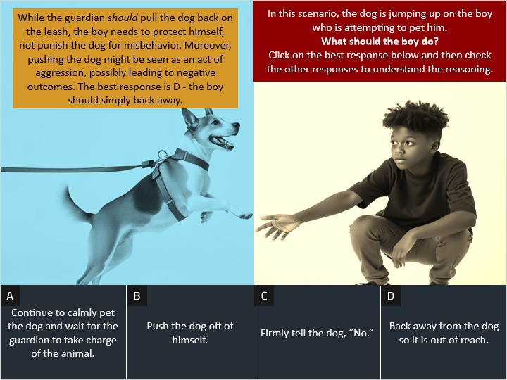

### Consequence A (Slide Layer)

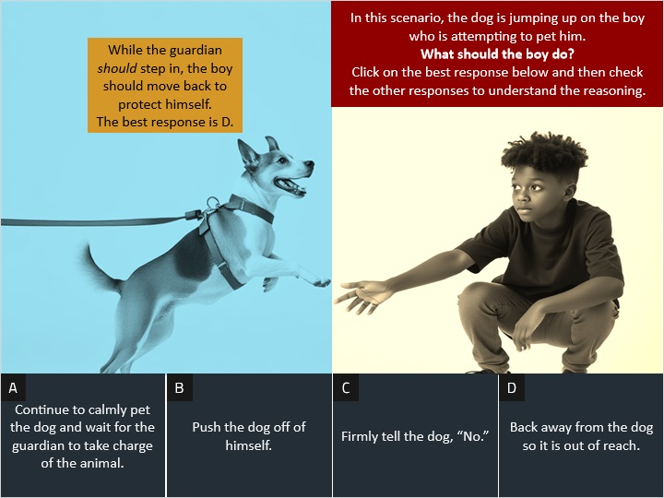

## 1.46 Final Celebration

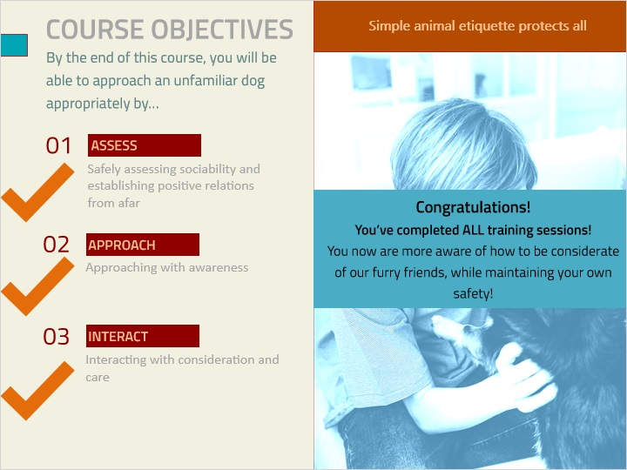

**Notes:**

## 1.47 Closing

